**Software Project and Process Management**

**Course Project Planning Document**

**——Online Snack Store**

**Team Member**

1853543 黄弋鸥

1852345 毛靖鑫

1853898 谭忠煜

1851350 陈扬森

**1. General View of Project**

1.1 Background

1.2 Vision

1.3 Requirement

1.4 Assumptions

1.5 Executive Summary

1.6 Analysis of Alternatives

**2. Project Initiation and Scope Definition**

2.1 Requirement Management

2.1.1 Determination and Negotiation

2.1.2 Review and Revision

2.2 Feasibility Analysis

2.2.1 Functions

2.2.2 Constraint

2.2.3 Features

2.3 Scope

**3. Project Planning and Charter**

3.1 Human Organization

3.1.1 Stakeholders

3.2 Activity Planning and Schedules

3.2.1 Work Breakdown Structure (WBS)

3.2.2 Activity List

3.2.3 Critical Path Graph

**4. Risk Management**

4.1 Risk Management Plan

4.2 Categories of Risk

4.3 Risk Identification

4.4 Risk Analysis, Assessment and Prioritization

4.5 Risk Prevention

4.6 Risk Actions

4.7 Risk Evaluation

4.7.1 PERT Activities Schedule

4.7.2 Project Cycle Activities Network Diagram

**5. Resource Allocation**

5.1 Resource Category

5.2 Identify Resource Requirement

5.3 Resource Scheduling

**6. Monitor and Control**

6.1 Project control framework

6.2 Data Collection

6.3 Progress Visualization

6.4 Cost Monitoring

6.5 Earned Value Analysis

6.6 Change Control

**7. Project Implementation**

7.1 Process Model

7.2 Development Techniques

**8. Prototype**

**9. References**

**1. General View of Project**

**1.1 Background**

Nowadays, online shopping is very developed, but it will still take two to three days for transportation. We hope to build a snack trading platform between the small snack shops nearby the campus and the students, where students can buy snacks easily in less than one day, therefore students don’t have to worry about not being able to easily buy the snacks they want but can’t find at any school shop and can choose cheaper snacks online instead of buying more expensive one offline at school. at the same time, businessman can sell their snacks more widely. They don’t need to get a storefront in the school to run the snack business, they only need to have a legal business qualification to get the income.

**1.2 Vision**

A new business of an e-commerce company will be initiated: a virtual Snack Store The system to support it must manage the acquisition and selling processes of the company.

Before our online snack shops appeared, there were two main ways for students to get snacks. One was to buy the snacks they wanted through e-commerce platforms such as Taobao and JingDong, but it usually took two to three days to receive the snacks.

The other way is to buy snacks through takeout in platforms like Eleme and Meituan. However, few merchants sell snacks on these takeout platforms, and there are not many kinds of snacks. Besides, students can only buy from one merchant at a time, otherwise they will have to bear the freight for many times if they buy from multiple merchants.

**1.3 Requirement**

Access of the game store for merchants and management of the company must be accomplished through a Web site. The user can access it via PC or mobile device.

The system must allow the customer to search our system for his or her favorite snack and add the snack to the shopping cart or wish list. Players who live in different areas can easily see and buy all the goods that can be delivered to snack shops in one day. Most importantly, they need to confirm the quality of the snacks sold in the stores they visit. To ensure this, the system must maintain an unbiased product rating system where all users can refer to previous reviews by others.

After the purchase of certain snacks, and after the purchase of snacks to convey their personal opinions on the product, such as the freshness of the product, how the product looks, etc.

The system must provide a platform for sellers to add new products and manage information about their products and easily manage orders. The function of product information management belongs only to the seller, ordinary users do not have these rights. In addition, in order to meet the needs of merchants, the system must generate reports on top selling items and profiles of consumer groups, and recommend buying games based on past customer interests. In addition, the system must have the ability to forecast sales in order to provide better decisions (inventory, reorder products, etc.) on a solid basis. In addition, the system must have a procurement network and procurement time management system, so as to purchase the goods purchased by the user within the specified time within the specified stores. When an order is set to be delivered, the system should be able to make a decision about the most economical method of purchase, provided that the deadline can be met

**1.4 Assumptions**

1. No pirated snacks are stored or sold.

2. There are no non-joint venture retailers to join and obtain approval

3. No retailer too far away to buy joins the sales network

4. The marketing manager signs the supply contract through E-mail instead of the management system.

5. All commodities shall be purchased and distributed by our logistics system.

6. Master customer servSnack store knowledge and skills.

7 Customer servSnack store staff are familiar with how to purchase products through the system.

8. Customers use Alipay or WeChat wallet to pay the order.

**1.5 Business Case： Executive Summary**

**1.5.1 Brief description of the problem or opportunity**

**Problem**: In the early stages of platform development, there needs to be enough novel snack content for players to choose, which requires adequate communication with snack wholesalers. At the same time, make sure that the content of the transaction is legal. In the transitional stage of the development of the website platform, the transaction volume increased, and the transaction content increased. It is necessary to control the standardization and security of platform transactions, and at the same time pay attention to the creation of platform atmosphere.

**Opportunity**: If we can ensure full communication with manufacturers and users, and timely adjust the problems in the early stage of the platform, the transaction mode will be more standardized and safe. With a unique sales style, in the follow-up development, we will strive to create a platform atmosphere, guide the platform culture, and give users a greater sense of belonging, so as to lay a solid foundation for future development.

**1.5.2 Brief description of organization's goal and strategy**

The strategic goals of Online Snack Store include sustained growth and profitability, as well as increasing visibility and establishing a platform atmosphere. This project is based on the fashionable snack market. We hope to attract users' favor with comprehensive and exquisite snacks, and optimize the work of managers with concise and concise operation methods. It will improve the ability to serve customers through good early warning and feedback. And gradually build to become the preferred platform for users to buy snacks online, and provide long-term and stable services for our buyers and partners. In order to achieve this goal, it is necessary to ensure sufficient channels for the purchase of snacks, and allow a certain amount of expenditure in the early stage to increase the popularity of the platform and the complete snack purchase experience.

**The specific and current goals are:**

1. Meet business needs. Online Snack Store must be able to complete the procurement services provided to users and provide administrators with basic business functions such as income and expenditure lists.

2. Improve work efficiency. Online Snack Store needs to respond to some preset scenes and optimize management for administrators to improve work efficiency.

3. Improve profitability. ICE needs to complete the sales report and the summary of inventory information. And so on, so that managers can adjust business strategies in time to obtain greater profits.

4. Strengthen the company's brand. Online Snack Store is committed to improving buyers' buying experience, enhancing platform awareness, strengthening atmosphere building, and improving profitability from the side.

**1.5.3 Description of project's MOV and how it ties to the organizational goal and strategy**

MOV：

|  |  |
| --- | --- |
| Area of Impact | The project will be successful if ... |
| Customer | In 3 months, 60% of customers will visit our website at least once a week. |
| Strategic | We will become the direct sales contractor for at least 10 kinds of snacks in East China before May 1 next year. |
| Financial | By the end of the next quarter, our game sales will grow from 3% to 6%. |
| Operational | By the end of this fiscal year, our inventory turnover rate had increased by 15%. |
| Social | Next year, the number of accidents on our platform will be reduced to zero |

**How it ties to the organizational goal and strategy:**

Our tailor-made MOV can help us acquire a group of stable and loyal customers, which will ensure the long-term profitability of our platform, and will also increase the platform’s visibility and enhance brand charm.

Our MOV formulated according to the strategy can help us improve our business competitiveness, and we need to introduce better talents to improve the efficiency and profitability of the platform.

The MOV we have established in the financial sector can help us increase the sales of games. This is an important way to increase the profitability of the platform, and it is also an effective means to obtain sufficient funds to support the long-term development of the platform.

The MOV we formulated in the social field can ensure that the operation of the platform meets the specifications, and can effectively ensure the security of the property information of employees and users, which is also a great help to promote the development of our company.

**1.5.4 Description of each option or alternative analyzed**

1. Do nothing. As the business is progressing smoothly, we can continue to operate without this new project.

2. Adopt applications developed by different fields or departments within the organization.

3. Redesign or reengineering the existing system.

4. Purchase off-the-shelf application packages from software vendors.

5. Use internal resources to custom build new applications or outsource development to another company.

6. Use most of the existing hardware and software to design and implement some new functions internally.

**1.5.5 Explanation of recommended alternative**

Designing and implementing new intranet functions internally using most of the existing hardware and software may be the best choice. On the one hand, making full use of the existing hardware and software can control the development cost. On the other hand, if the design is redesigned and completely outsourced, the progress and quality of the development can hardly be guaranteed. Purchasing off-the-shelf application packages not only requires a lot of docking work, but also a huge expense. Therefore, designing and implementing new intranet functions internally using most of the existing hardware and software may be the best choice.

**1.5.6 Objectives of writing this business case**

1. Specify all possible impacts, costs and benefits in detail.

2. Be clear and logical when comparing the cost/benefit impact of each alternative.

3. Reach the goal by including all relevant information.

4. Summarize the research results systematically.

**1.6 Business Case: Analysis of Alternatives**

**1.6.1 Methodology of how alternatives will be analyzed**

**Data collection methods**

1. Stakeholder suggestions: In major decisions that affect the effectiveness of the project, we need to respect the opinions of stakeholders and conduct full discussions with them to ensure that the interests of stakeholders are not harmed to the greatest extent

2. References to similar business cases: We can refer to similar business cases. The methods they have adopted and the results achieved will be a lesson for us. We can learn from what they did well, and learn from what they did not

3. Estimates based on actual conditions: The business case is only of reference value and cannot be followed blindly. The characteristics and situation of each project are unique. We need to consider our own actual conditions to create our own characteristics

**Metrics used and reasons**

1. Economic feasibility — Although a cost/benefit analysis will be conducted to look at the alternatives in greater depth, some alternatives may be too costly or simply not provide the benefits envisioned in the problem statement. At this point, an organization may evaluate an alternative in terms of whether funds and resources exist to support the project.

2. Technical feasibility—Technical feasibility focuses on the existing technical infrastructure needed to support an IT solution. Will the current infrastructure support the alternative? Will new technology be needed? Will it be available? Does the current staff have the skills and experience to support the proposed solution? If outsourcing, does the vendor or company have the skills and experience to develop and implement the application?

3. Organizational feasibility—Organizational feasibility considers the impact on the organization. It focuses mainly on how people within the organization will adapt to this planned organizational change. How will people and the way they do their jobs be impacted? Will they accept this change willingly? Will business be disrupted while the proposed solution is implemented?

4. Other feasibilities—Depending on the situation and the organization, a business case may include other issues, such as legal and ethical feasibility.

**1.6.2 Presentation of results that compares each alternative**

|  |  |  |  |  |  |  |
| --- | --- | --- | --- | --- | --- | --- |
| No. | Economic feasibility | Technical feasibility | Organization al feasibility | Sensitivity analysis | Risks | Assumptions |
| 1 | None | None | None | None | None | No investment, no return |
| 2 | Feasible | Feasible | Not Feasible | Not Sensitive | Low | May adversely affect the work of other people within the organization |
| 3 | Not feasible | Not feasible | Feasible | Sensitive | High | May cause serious delays in project progress |
| 4 | Not feasible | Feasible | Feasible | Sensitive | Low | May cause large financial expenditures |
| 5 | Feasible | Feasible | Feasible | Sensitive | High | Outsourcing cannot guarantee the quality of the software, and also affects the development progress of possible related projects |
| 6 | Feasible | Feasible | Feasible | Not Sensitive | Low | A relatively stable choice in all aspects |

**1.6.3 Proposed recommendation**

It is best to use most of the existing hardware and software to design and implement new intranet functions internally. From an economic point of view, this method will not cause too much overhead, and the direct purchase of external software packages will greatly increase development costs. Technically, this method will not have too high technical requirements, unlike redesigning the system will require a lot of manpower and material resources. In terms of organization, this method can complete the work independently internally, and will not rely on other departments to cause delays in the progress of other projects. From a sensitivity point of view, this method is consistent with conventional methods and does not cause commercial sensitivity. From a risk point of view, the risk of this method is low, and like product outsourcing, it will not be difficult to control and ensure the quality and schedule.

**2. Project Initiation and Scope Definition**

**2.1 Requirement Management**

**2.1.1 Determination and Negotiation**

With the development of platforms such as Taobao T-mall Jindong, today, digital store seems to have become the first choices for people who want to purchase snacks which cannot be found easily in local shops. However, users still tend to purchase snacks simply from online store for stable shopping experience or other purposes, and as more and more players enjoy exploring snacks from everywhere, this market is still booming.

In such a large environment, we decided to create a sales platform specifically for the market, let major snack shops sell their products on the platform, users can purchase, communicate and other activities on this platform or sharing game purchase experience.

**2.1.2 Review and Revision**

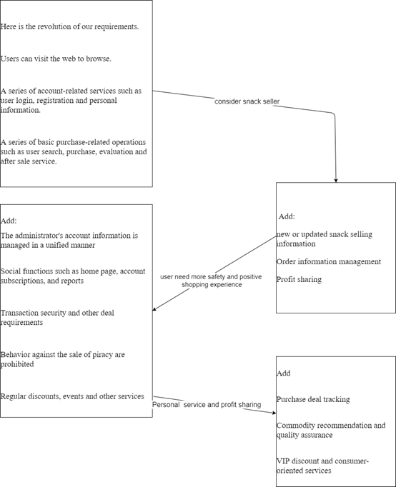

**2.2 Feasibility Analysis**

**2.2.1 Functions**

Functions for users

◦ The user logs in to Snack Store

◦ The user searches for snacks in Snack Store

◦ The user views snacks categories in Snack Store

◦ The user views snacks sellers in Snack Store

◦ The user views personal homepage in Snack Store

◦ The user views order information in Snack Store

◦ The user views shopping cart information in Snack Store

◦ The user views snack details information in Snack Store

◦ The user purchases snacks in Snack Store

◦ The user adds the snacks to the shopping cart in Snack Store

◦ The user adds the snacks to the wish list in Snack Store

◦ The user modifies personal information in Snack Store

◦ The user adds delivery address in Snack Store

◦ The user rates the order in Snack Store

Functions for sellers

◦ The seller logs in to snack store

◦ The seller views personal information in snack store

◦ The seller modifies personal information in snack store

◦ The seller views game list in snack store

◦ The seller modifies game information in snack store

◦ The seller removes game in snack store

◦ The seller adds game in snack store

◦ The seller views order in snack store

◦ The seller modifies the order information in snack store

◦ The seller delivery the game product in snack store

Functions for administrators

◦ The administrator logs in to snack store.

◦ The administrator exits from snack store.

◦ The administrator makes announcement in snack store.

◦ The administrator manages users' account in snack store.

◦ The administrator checks users' comments in snack store.

◦ The administrator handles with report information in snack store.

◦ The administrator makes recommend information in snack store.

Functions for analysts

◦ snacks that are better sold in the second quarter than the first quarter

◦ Which categories of snacks are the most profitable ones?

◦ What is the average time between the order placed and shipped?

◦ significant difference between snacks sold by different sellers in terms of profitability?

**2.2.2 Constraint**

Customers can pay by credit card, Alipay or WeChat.

All transactions should be safe.

You can access the system through PC, mobile devices and other websites.

Users (customers) can discuss and share their opinions on snacks, but our system only pushes information and recommendations of snacks that can be sent to users within a day

**2.2.3 Features**

1. Performance requirements:

◦ In 95% of the cases, the response time in the general period does not exceed 1.5 seconds, and the peak period does not exceed 4 seconds.

◦ The final estimated number of users is 10,000, the number of daily logged-in users is about 3,000, and the network bandwidth is 100M bandwidth.

◦ The system can satisfy 5,000 user requests at the same time and provide browsing functions for 10,000 concurrent users.

2. Security requirements:

◦ Strict permission access control, after identity authentication, users can only access data within their permission range and can only perform operations within their permission range.

◦ Can withstand general malicious attacks from the Internet. Such as virus attacks, password guessing attacks, hacking, etc.

◦ Different users have different identities and permissions. It is necessary to provide trusted authorization management services under the premise that the user's identity is true and trustworthy, to protect data from illegal / unauthorized access and tampering, and to ensure

data confidentiality and integrity.

3. Reliability requirements:

◦ There are prompts for input and data are checked to prevent abnormal data.

◦ The system is robust and should be able to deal with all kinds of abnormal conditions that occur during the operation of the system, such as: human operation errors, illegal data input, and hardware device failure. The system should be able to handle it properly and avoid it properly.

4. Data confidentiality requirements:

◦ Network transmission data should be encrypted. It is necessary to ensure that the data is not peeped, stolen, or tampered with during the collection, transmission, and processing. Business data needs to be encrypted during storage to ensure that it cannot be cracked.

5. Ease of use requirements:

◦ 60% of users can master the use and purchase methods through the experience of other platforms and the description of the platform within 5 seconds of first seeing the platform.

6. Maintainability requirements

◦ After receiving the modification request, the ordinary modification should be completed within 1 to 2 days; for the evaluation of the major demand or design modification should be completed within 1 week.

◦ 90% of the bugs were modified within 1 working day, and others within 2 working days.

**2.3 Scope**

Our Online Snack Store's strategic goals include continuous growth and profitability, as well as increasing popularity, fame and building a platform atmosphere. This project is based on the snack selling market. It hopes to attract users' favor with high quality, diverse snacks and convenience during purchase and optimize the work of managers with concise and refined operation methods.

Our system can provide users with safe guarantee and traceable commodity quality inspection. In order to achieve this goal, what we need to do is to strictly audit commodity selling institutions, select qualified sales channels, investigate snack wholesale channels, find out novel snacks, and strive to build a snack sharing and communication community culture.

Specific and direct goals are:

1. Meet business needs. Online Snack Store must be able to complete the purchase service provided to users, and provide administrators with basic business functions such as income and expenditure inventory reports.

2. Improve work efficiency. Online Snack Store needs to respond to some preset scenarios and optimize the management of administrators to improve work efficiency.

3. Improve profitability. Online Snack Store needs to complete the summary of sales reports, inventory information, etc., so that administrators can adjust business strategies in time to obtain greater profits.

4. Enhance corporate brand. Online Snack Store is committed to improving the buying experience of buyers, enhancing the visibility of the platform, strengthening the construction of atmosphere, and improving profitability.

**3. Project Planning and Charter**

**3.1 Human Organization**

This part mainly shows the organization of our group members, their character in our project and the way of communication, that’s how to compose these people together.

**3.1.1 Stakeholders**

|  |  |  |
| --- | --- | --- |
| **Role** | **Name** | **Responsibility** |
| Sponsor | All of us | Sponsor of this project, give request of requirement and change it during comprehension. |
| Project Manager | Huang Yiou | Responsible for monitor development progress, make decision on risk control and resource provision, and ensure software quality. |
| Resource Allocator | Huang Yiou | Responsible for the management of labor, equipment, technical resource. |
| Business Analyst | Chen Yangsen | Responsible for market survey and analysis of our project business cases. |
| Requirements  Analyst | Chen Yangsen | Responsible for communicating requirements with customers, assisting project manager to control and follow up requirement change. |
| Product  Architect | Mao Jingxin | Responsible for the design of the software part of the system structure and model. |
| Product Designer | Mao Jingxin | Responsible for the functional requirements of the project and product design part. |
| Risk Analyst | Tan Zhongyu | Responsible for risk analysis in the process of project. |
| Team Leader | Mao Jingxin | Responsible monitoring and controlling the progress of the project. |
| Team Member | All of us | Development team, responsible for the coding and deployment of the project. |
| Quality Assurance | Tan Zhongyu | Responsible for test cases design, test execution and evaluation of the test execution process. |

**3.2 Activity Planning and Schedules**

This part mainly talks about the activity plan of our project: how to divide our project into part and key activities and how to manage these activities to make best use of our time.

**3.2.1 Work Breakdown Structure (WBS)**

This part we will divide our project into several main parts and figure out the key activities in it.

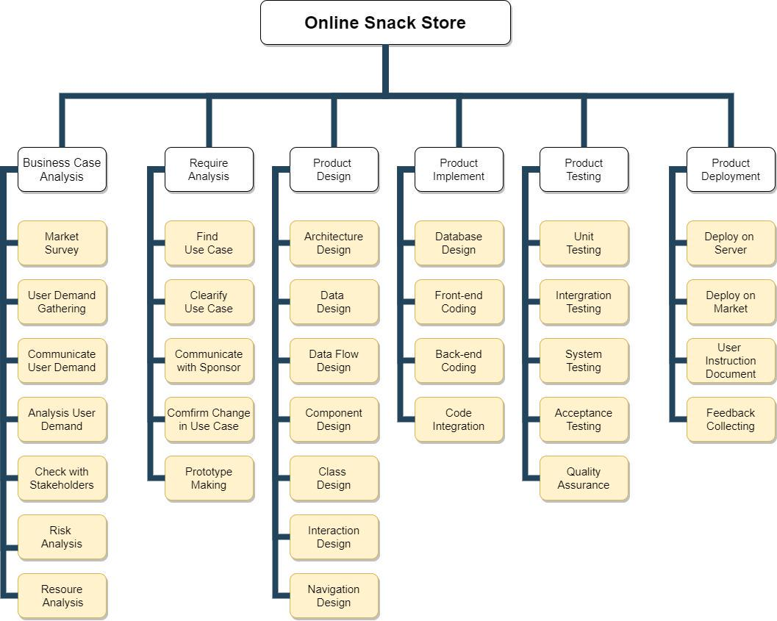

**3.2.2 Activity List**

This part we will figure out the key activities and list them.

|  |  |  |  |
| --- | --- | --- | --- |
| **No.** | **Name** | **Estimated Time (Week)** | **Dependency** |
| A | Business Case Analysis | 1 |  |
| B | Requirement Analysis | 1 | A |
| C | Architecture Design | 1 | B |
| D | Data Design | 1 | B |
| E | Component Design | 2 | B |
| F | Class Design | 2 | B |
| G | Interaction Design | 2 | B |
| H | Back-end Coding | 2 | C,D,E,F |
| I | Front-end Coding | 2 | G |
| J | Test & Quality Assurance | 5 | H,I |
| K | Project Deployment | 1 | K |
| L | Feedback Collecting | 1 | K |

**3.2.3 Critical Path Graph**

Our project will start at March 5th, and end at June 30th according to plan. It will take about 16 weeks.

The follow is the correspondent **Critical Path Graph**.

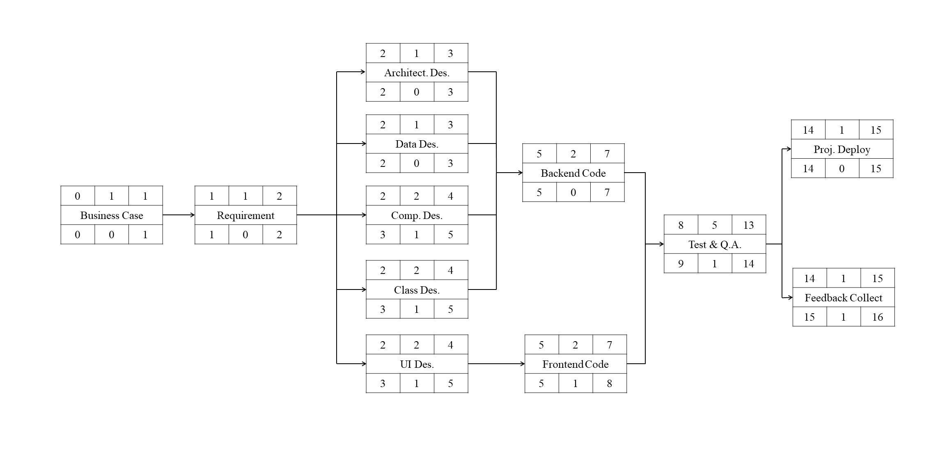

The follow is relevant **Gantt chart**.

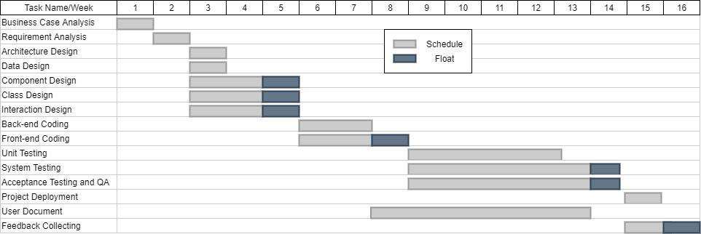

**4. Risk Management**

**4.1 Risk Management Plan**

Our team first formulated a risk management plan, based on the risk management steps of [**Project Management Institute**](https://www.pmi.org/)(**PMI**) risk management. Then the risks are determined from four parts: qualitative risk analysis and quantitative risk analysis. Every effort will be made to proactively identify risks in advance so that mitigation strategies can be implemented from the beginning of the project.

When analyzing the potential risks in the project, we adopted a risk identification method combining **checklist method** and **brainstorming method** and risk reduction techniques for each potential risk.

We manage risks according to priorities, the most likely and highest impact risks are added to the project schedule to ensure that the assigned risk manager take the necessary steps to implement the mitigation response at the appropriate time during the schedule.

Upon the completion of the project, during the closing process, the project manager will analysis each risk as well as the risk management process. Based on this analusis, the project manager will identify any improvements that could be made to the risk management process for future projects.

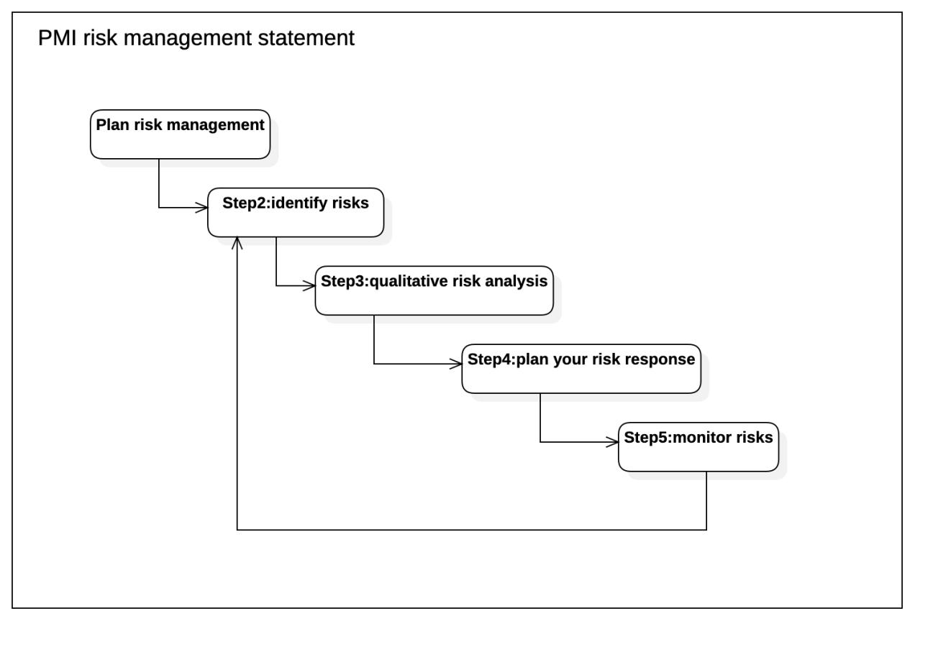

**4.2 Categories of Risk**

Project risks are those that could prevent the achievement of the objectives given to the project manager & team.

In the Software Project and Process Management Course Project **“Online Snack Store”**, we reference to “Lyytinen-Mathiassen-Ropponen” risk framework and we divided the risk factors into four parts.

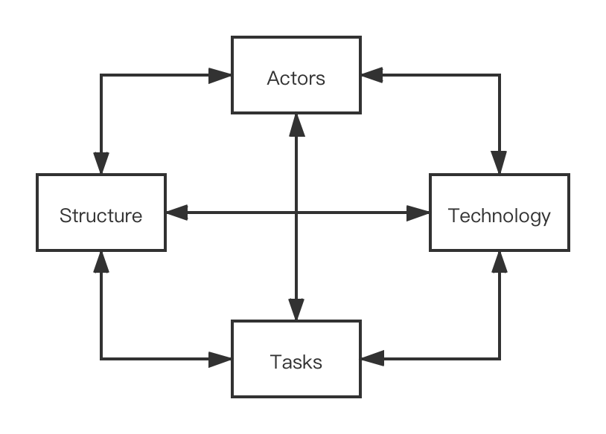

* **Actors**: main participants are the members of the group, among which the typical risks are mention below
  + changing of the staff
  + poor communication within the team leads to loss of valuable information of the project
* **Technology**: technology is the specific knowledge and tools using in the project, typical risk are mention below
  + tools used in the project development and implementation do not meet the project requirements
  + technology used in the project has defects, such as it is not suitable for the project or the team members are not familiar with the technology
* **Structure**: structure contains the planning structure, project structure, management structure and so on, typical risk are mention below
  + project management structure is not clear, which leads to the delay of each team member’s timely positioning of their own work
* **Tasks**: tasks involving specific activities of the project, typical risk are mention below
  + risk of requirement change
  + complexity of integration among various project components will delay the progress of the project
  + quality and performance risk of the OSS system;

**4.3 Risk Identification**

In the risk identification of this project, we adopted the risk identification method combining **Checklist method** and **Brainstorming method**, referred to checklists models such as **lyytinen model** and **Barry Boehm model**, and established our own checklists as follows:

|  |  |  |
| --- | --- | --- |
| Serial Number | Risk | Risk reduction techniques |
| R1 | Development tools need to be replaced during the development process | Carry out sufficient research and analysis on development tools;Use stable development tools |
| R2 | Development technology is too complicated | Develop project technical prototypes; Conduct technical training for employees |
| R3 | Real-time performance defects | Use prototype development;Simulate the operation of the prototype |
| R4 | User interface error | Use prototype development; Perform task analysis; Let users participate in project development |
| R5 | Personnel changes | More than one person participated in the core work of the project in order to familiar with the project process |
| R6 | Team members did not communicate well | Agree on the way of communication; Regular communication of work progress; The minutes of the meeting |
| R7 | Code integration issues | Convention code specification; Incremental development and integration |
| R8 | Technology adopted is flawed | Use familiar technology; Specially-assigned person to study the new technology needed |
| R9 | Change to requirements specification during coding | Stringent change control proceduresHigh change thresholdIncremental development(deferring changes)Agree on the requirement change control process in writing and record the change request |

**4.4 Risk Analysis, Assessment and Prioritization**

In this project, we define the risk probability using score from 1 to 10, and we divide them into 4 levels from extra-high to extra-low. **Risk Probability Level Table**, **Risk Impact Level Table**, and **Risk Level Decision Table** are shown below:

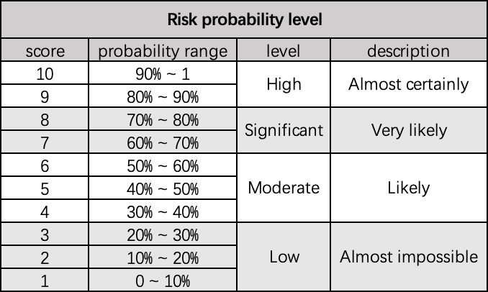

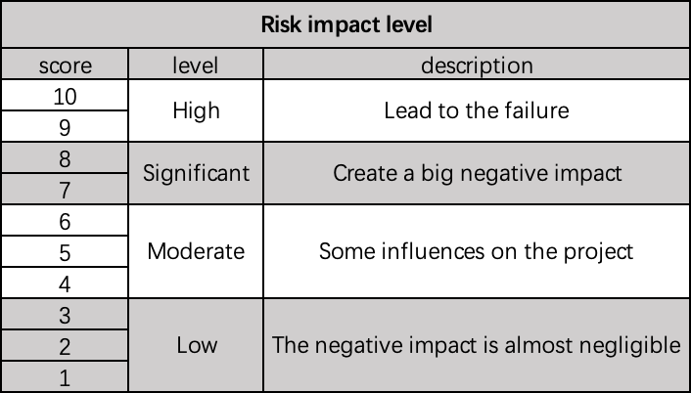

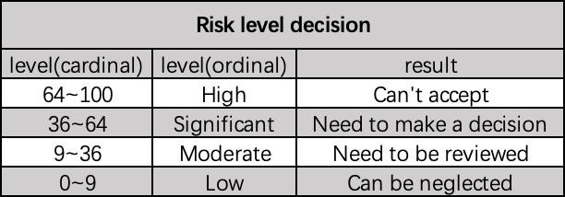

After defining the levels, we analyzed the potential risks in the project from the four aspects mentioned above.

We simulate the risk exposure during our brainstorming, and we use **Barry Boehm’s method** for risk exposure assessment. And we use **risk exposure formula** for calculating.

|  |  |  |  |  |
| --- | --- | --- | --- | --- |
| Ref | Hazard | Probability | Impact | Risk |
| R1 | Development tools need to be replaced during the development process | 2 | 10 | 20 |
| R2 | Development technology is too complicated | 6 | 3 | 18 |
| R3 | Real-time performance defects | 6 | 6 | 36 |
| R4 | User interface error | 5 | 8 | 40 |
| R5 | Personnel changes | 2 | 8 | 16 |
| R6 | Team members did not communicate well | 5 | 5 | 25 |
| R7 | Code integration issues | 4 | 5 | 20 |
| R8 | Technology adopted is flawed | 3 | 10 | 30 |
| R9 | Change to requirements specification during coding | 8 | 8 | 64 |

The **probability impact matrix** is as follow:

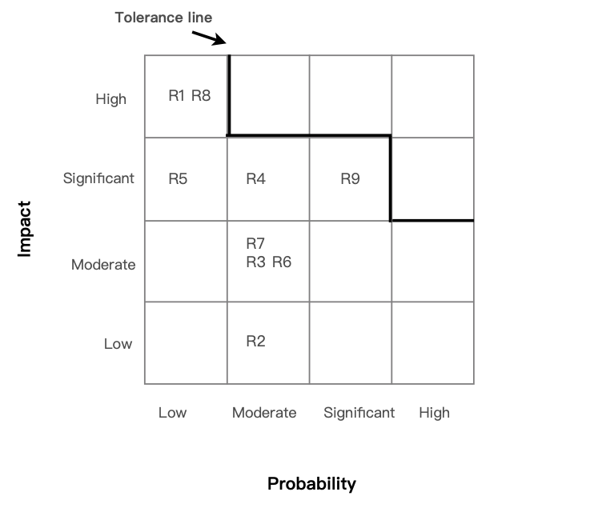

**4.5 Risk Prevention**

1. **For risk R1**, Investigate common development tools in the industry at the beginning of the project and generate a survey document
2. **For risk R2**, Provide technical training for employees involved in the implementation of related technologies at the early stage of the project
3. **For risk R3**,Develop the feasibility and real-time performance of the prototype verification technology in the early stage of the project
4. **For risk R4**, Carry out sufficient requirements analysis and prototype design of the user interface in the early stages of the project
5. **For risk R5**, everyone is involved in the core work of the project to ensure that the change of personnel will not make the project unable to proceed normally
6. **For risk R6**, the group shall agree on the communication method at the beginning of the project and regularly communicate the schedule of work progress. If necessary, the meeting minutes shall be taken to minimize the possibility of risk R7
7. **For risk R7**, to start the project code writing, agree on the development environment and code specification, annotation specification, etc., in the development process, incremental development and intergration to reduce the final workload
8. **For risk R8**, when encountering a risk bottleneck, turn the head and select experienced or familiar technologies. At the same time, a team member can be allowed to study and learn new technologies to pave the way for the implementation of the project
9. **For risk R9**,at the beginning of the project construction, agree on the requirement change control process with the user, record and archive the user’s requirement change application

**4.6 Risk Actions**

According to the formula of **Risk reduction leverage(RRL)**

And we picked out and examined what appear to be the most threatening risks to the project, creating and maintaining our findings in a **Risk Register**.

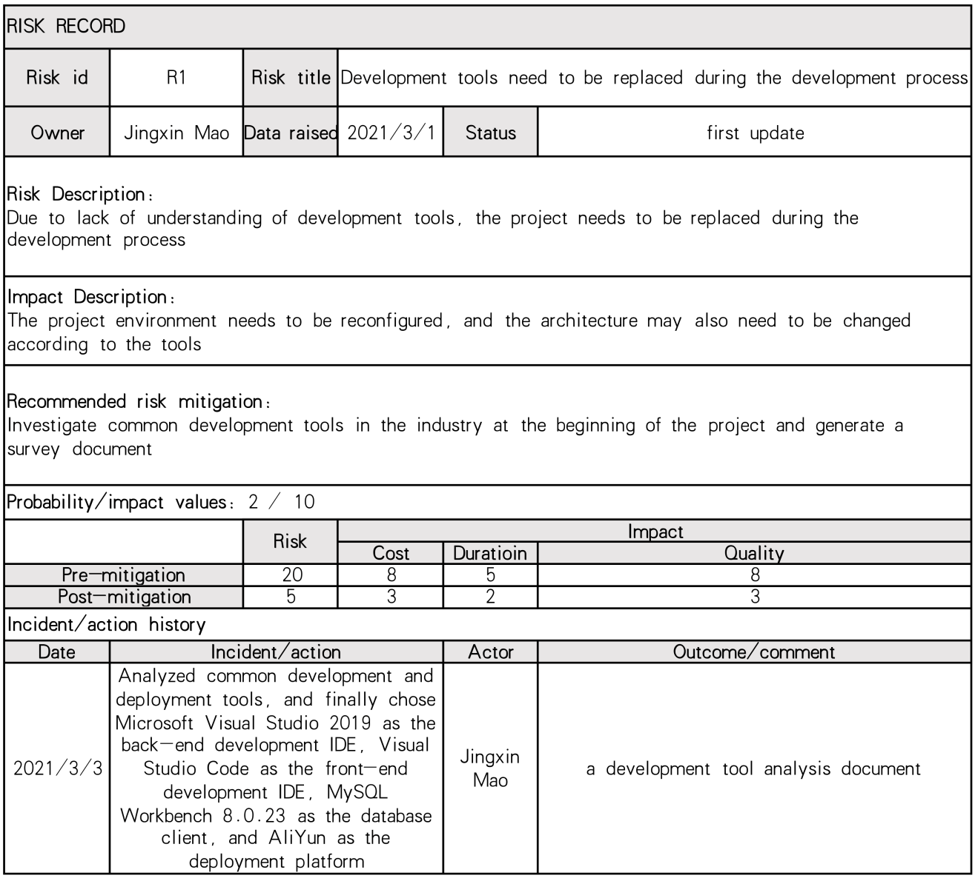

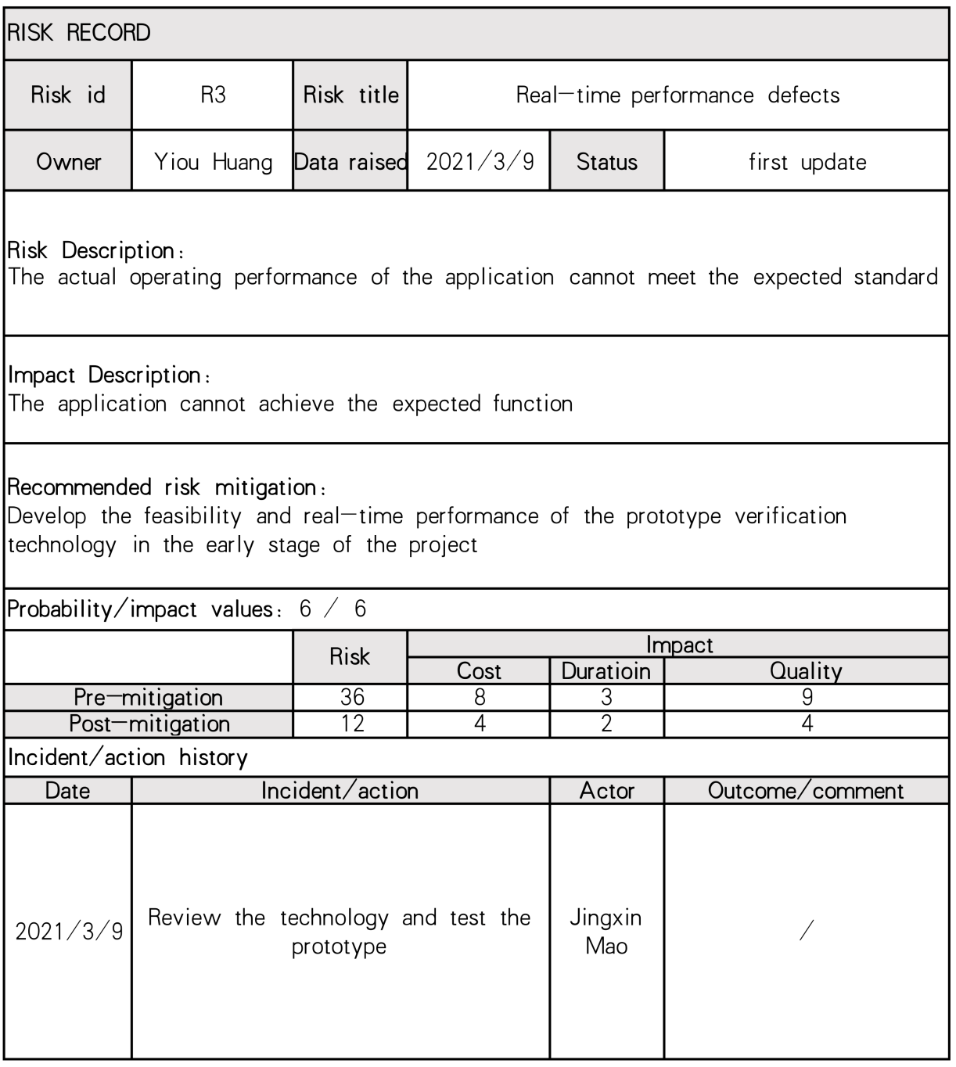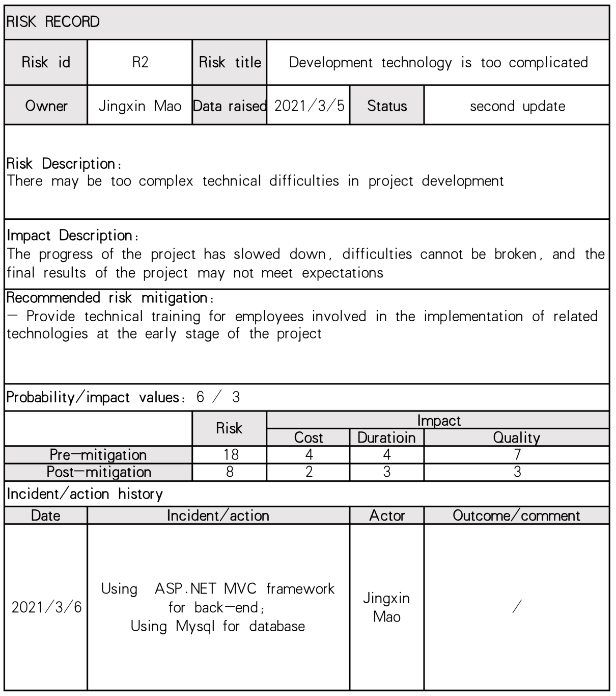

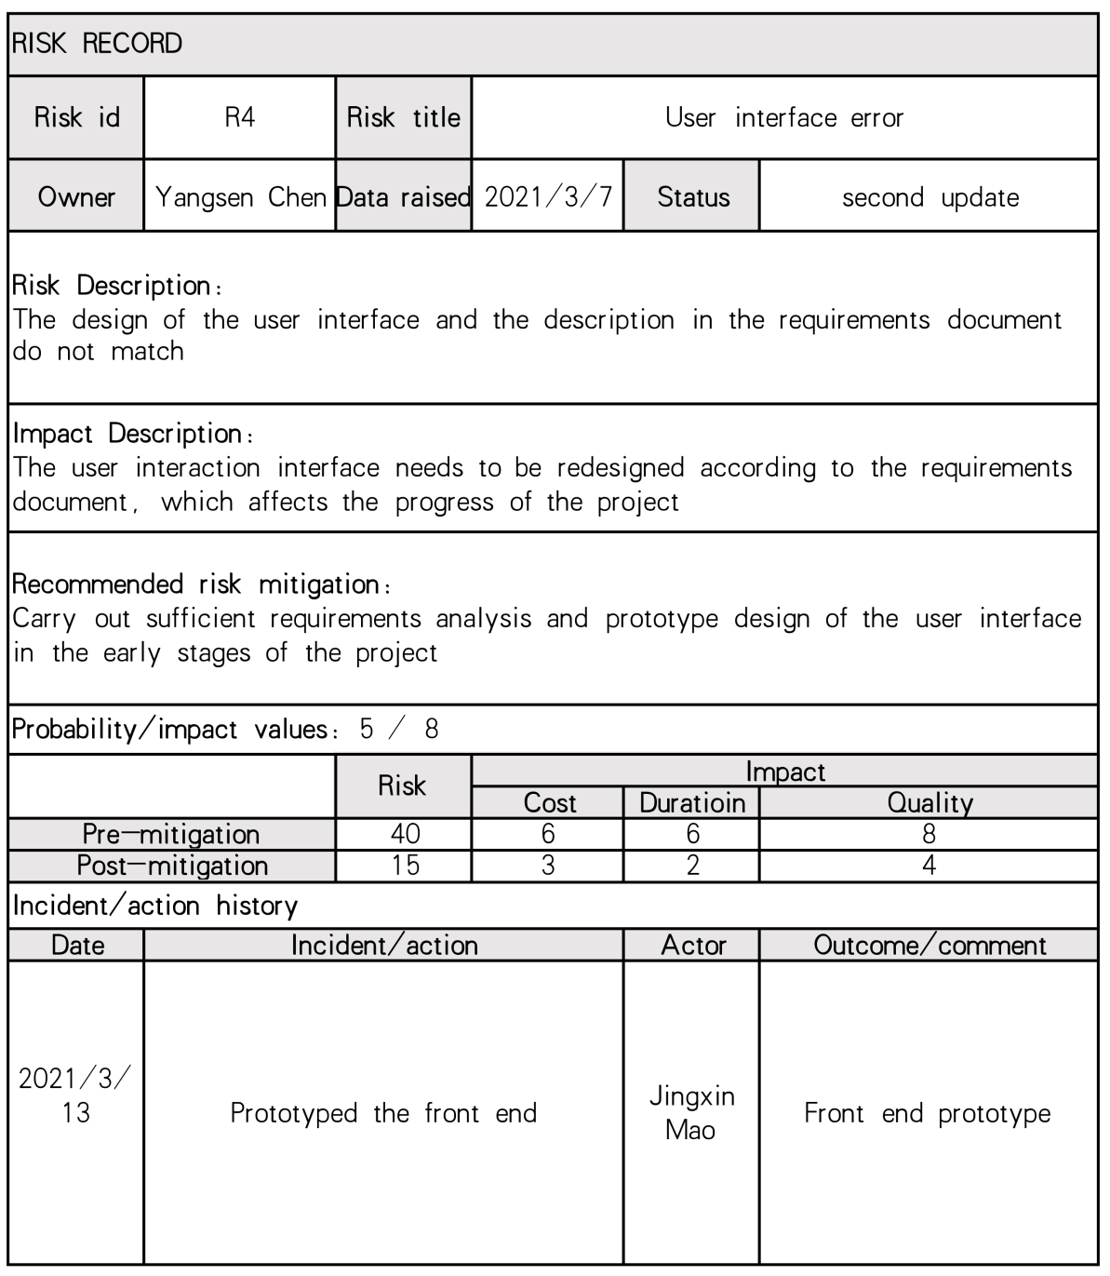

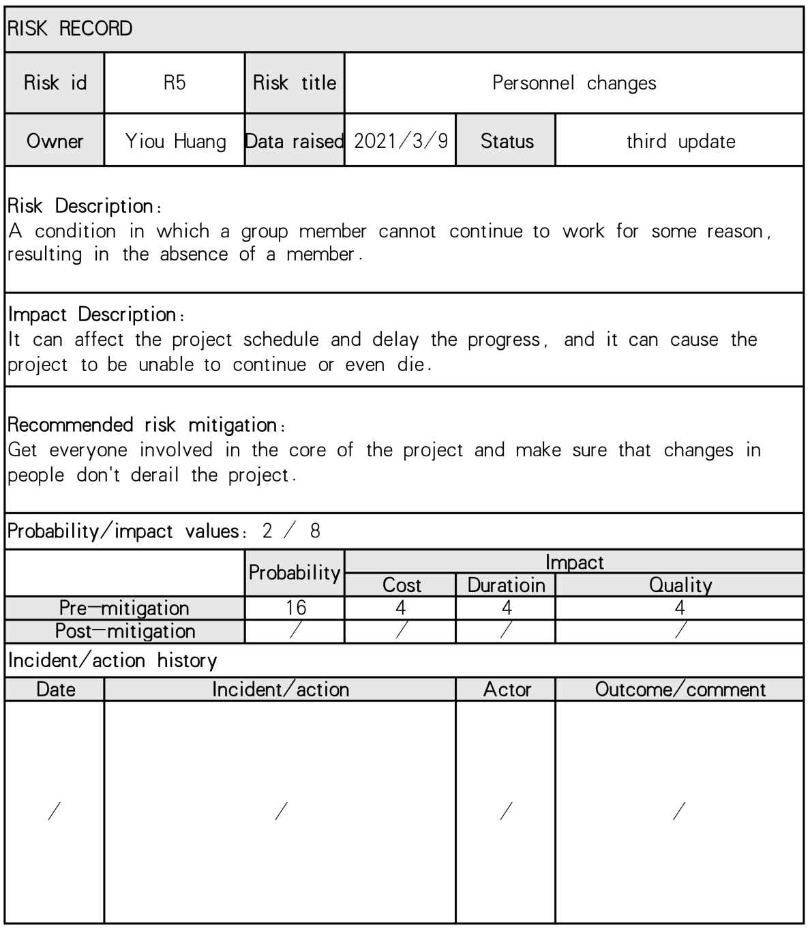

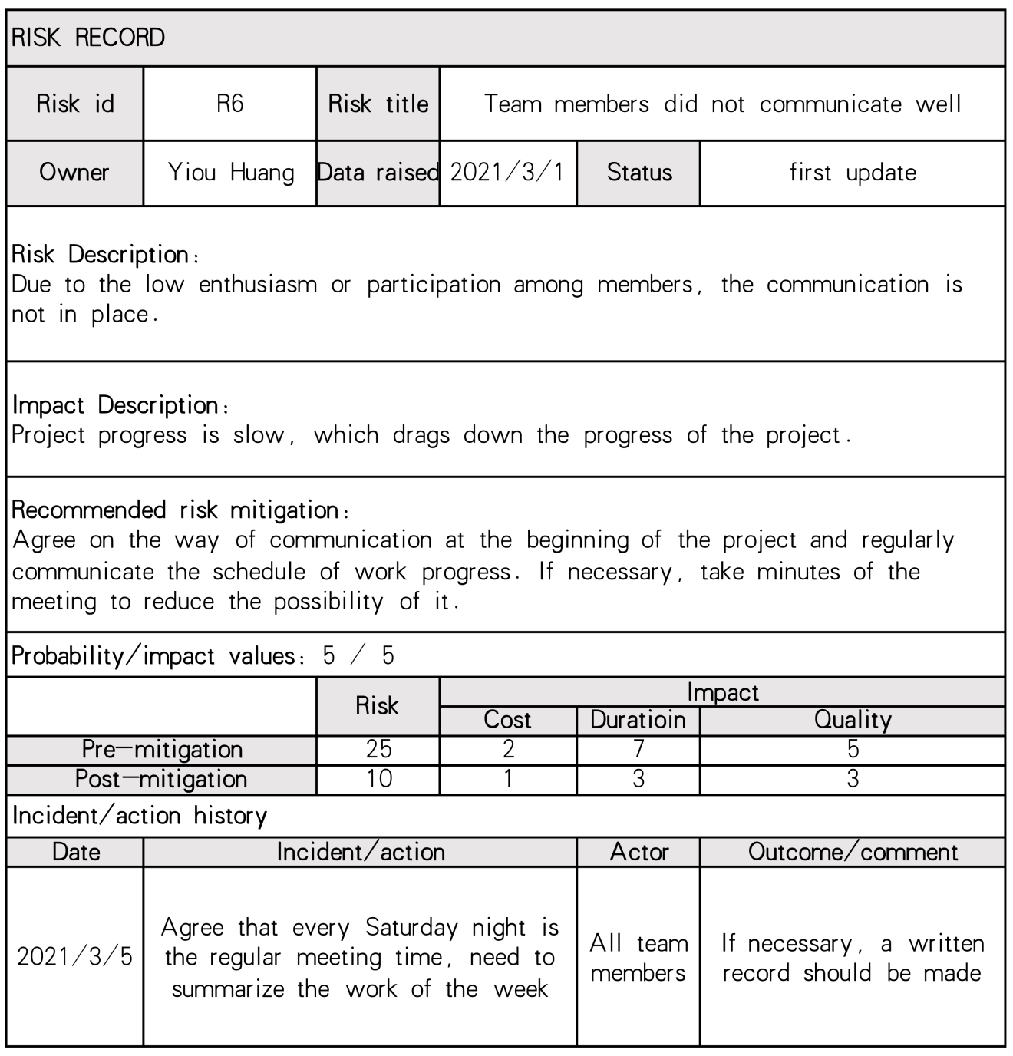

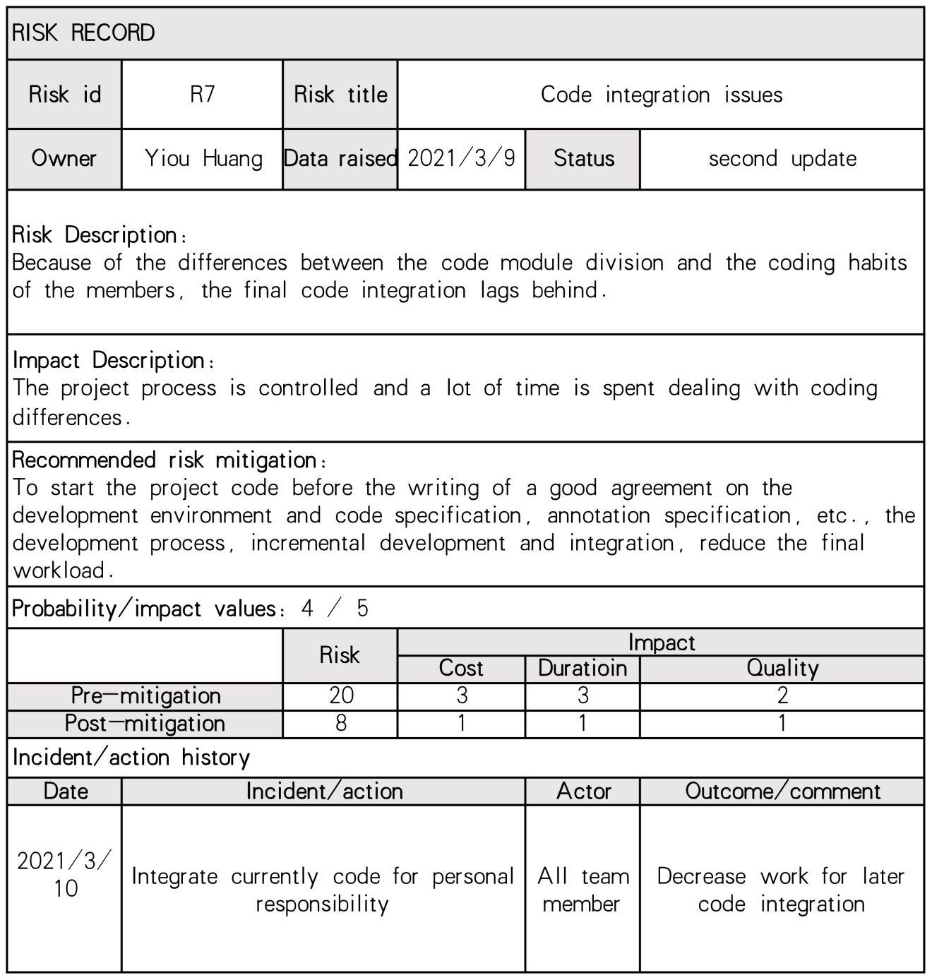

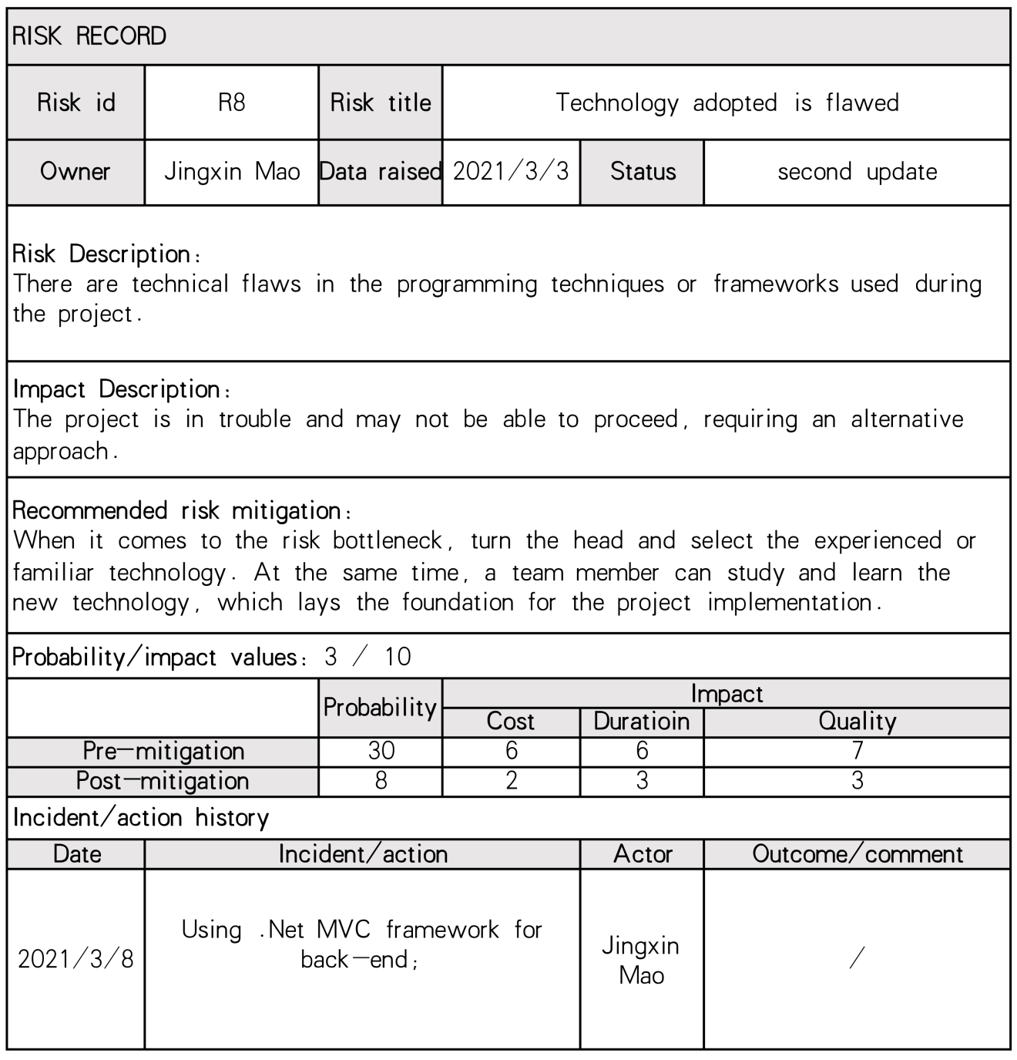

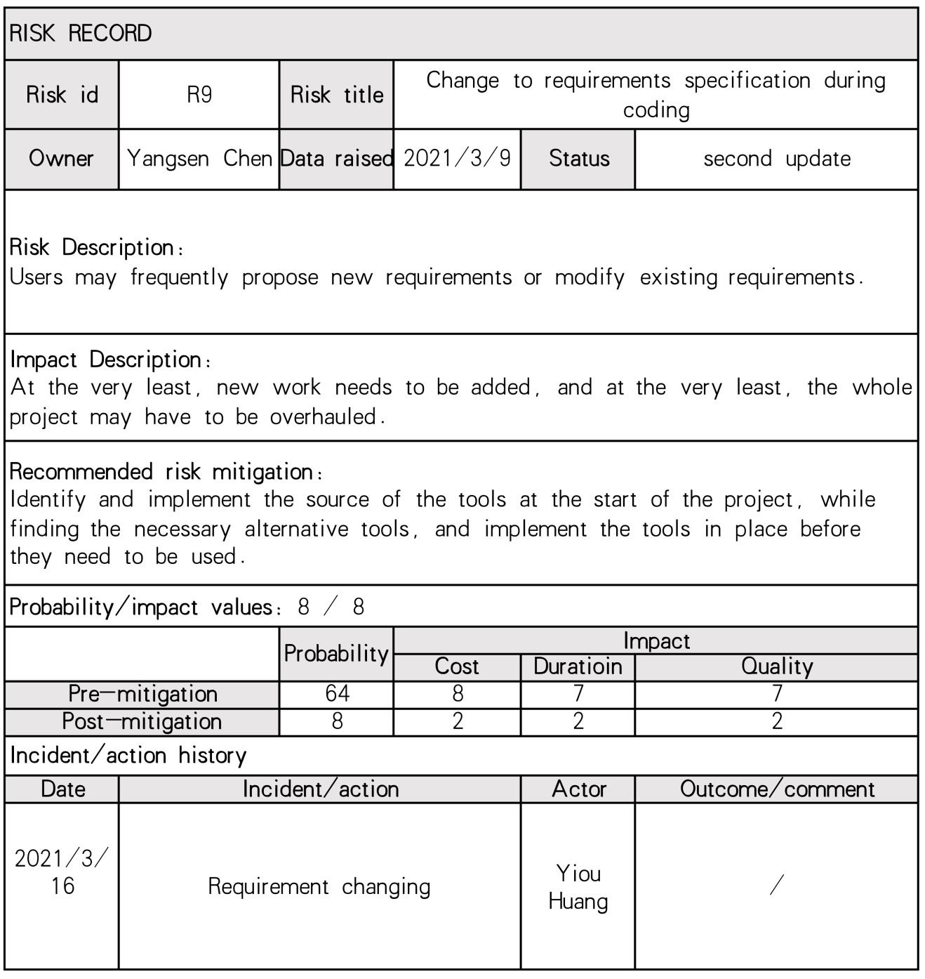

**4.7 Risk Evaluation**

We use **PERT(Program Evaluation and Review Technique)** for risk evaluation. PERT was developed to deal with the uncertainly surrounding estimates of task durations.

First we divided the global task into sub-task, and estimating for three times, **Most likely time(a)**, **Optimistic time(m)** and **Pessimistic time(b)**, then using formula to calculating **Expected Duration** and **Activity Standard Deviations**

**te=(a+4m+b)/6**

**s=(6-a)/6**

**4.7.1 PERT Activities Schedule**

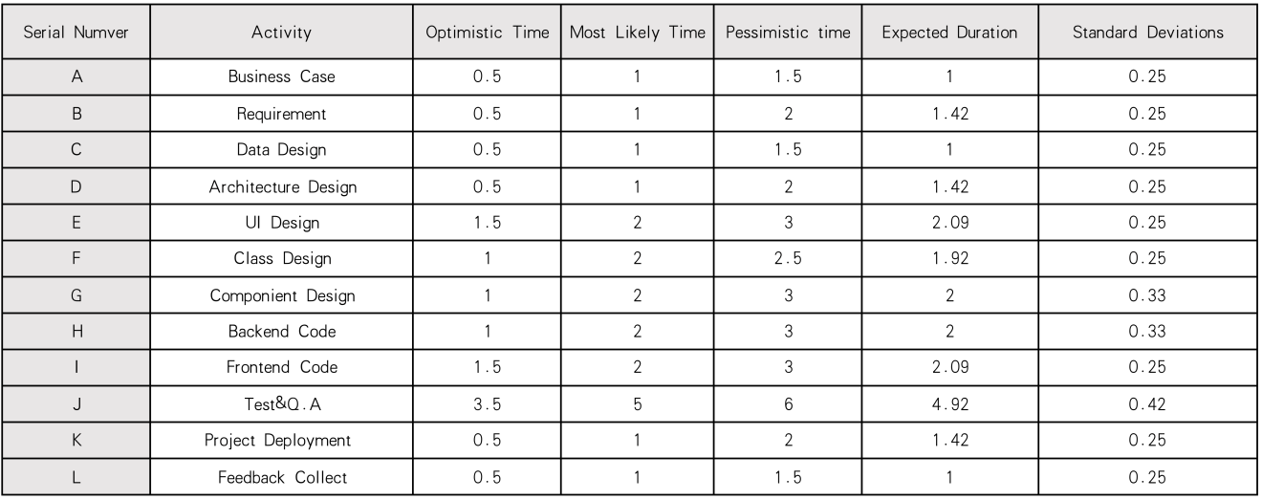

**4.7.2 Project Cycle Activities Network Diagram**

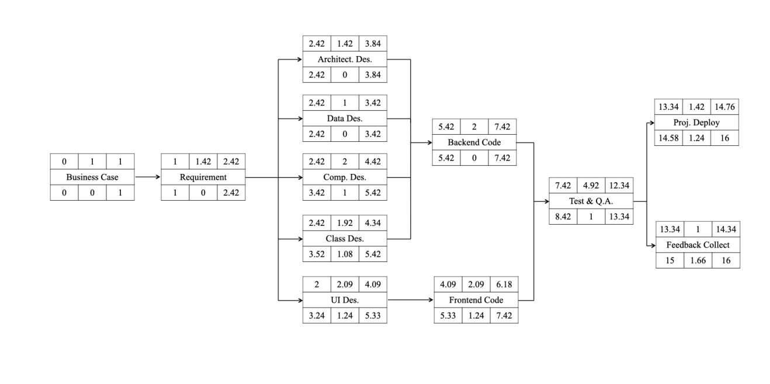

**5. Resource Allocation**

**5.1 Resource Category**

At the first stage of resource allocation part, we should make a resource allocation plan to list all the resources that will be required along with their expected level of demand.

The following table shows the **resource category**.

|  |  |  |
| --- | --- | --- |
| **Res. Category** | **Details** | **Available Resource** |
| Labor | The most important category. It means members of the development project team such as the PM, systems analysts, developers and so on. | Project Manager  Business Analyst  Analyst  Architect  Designer  Team Leader  Team Member  Tester |
| Time | Time is also important and may be short if there are some emergency in our project. | Our project will start at March 5th, and end at June 30th according to plan. It will take about 16 weeks. |
| Space | Space is already available, we conduct our work in our own space when seperated and in a public meeting when together. | Our own workspace  A public meeting room, sometime work online, need one online meeting room |
| Facilities | All basic equipment should be considered. | Laptop  Tables  Chairs  Server to deploy our product |
| Materials | Items that are consumed, rather than equipment that is used. | Disks  Paper |
| Services | Needed service provided by other service developers. | Ali cloud service  Online meeting service |
| Money | Secondary resource, used to buy other resources. | Money for employee, buying equipment, materials and services |

**5.2 Identify Resource Requirement**

The allocation of resources to activities will lead us to review and modify the ideal activity plan. We should revise our project plan after resource allocation.

Firstly we divided our **activity network analysis** into several stages.

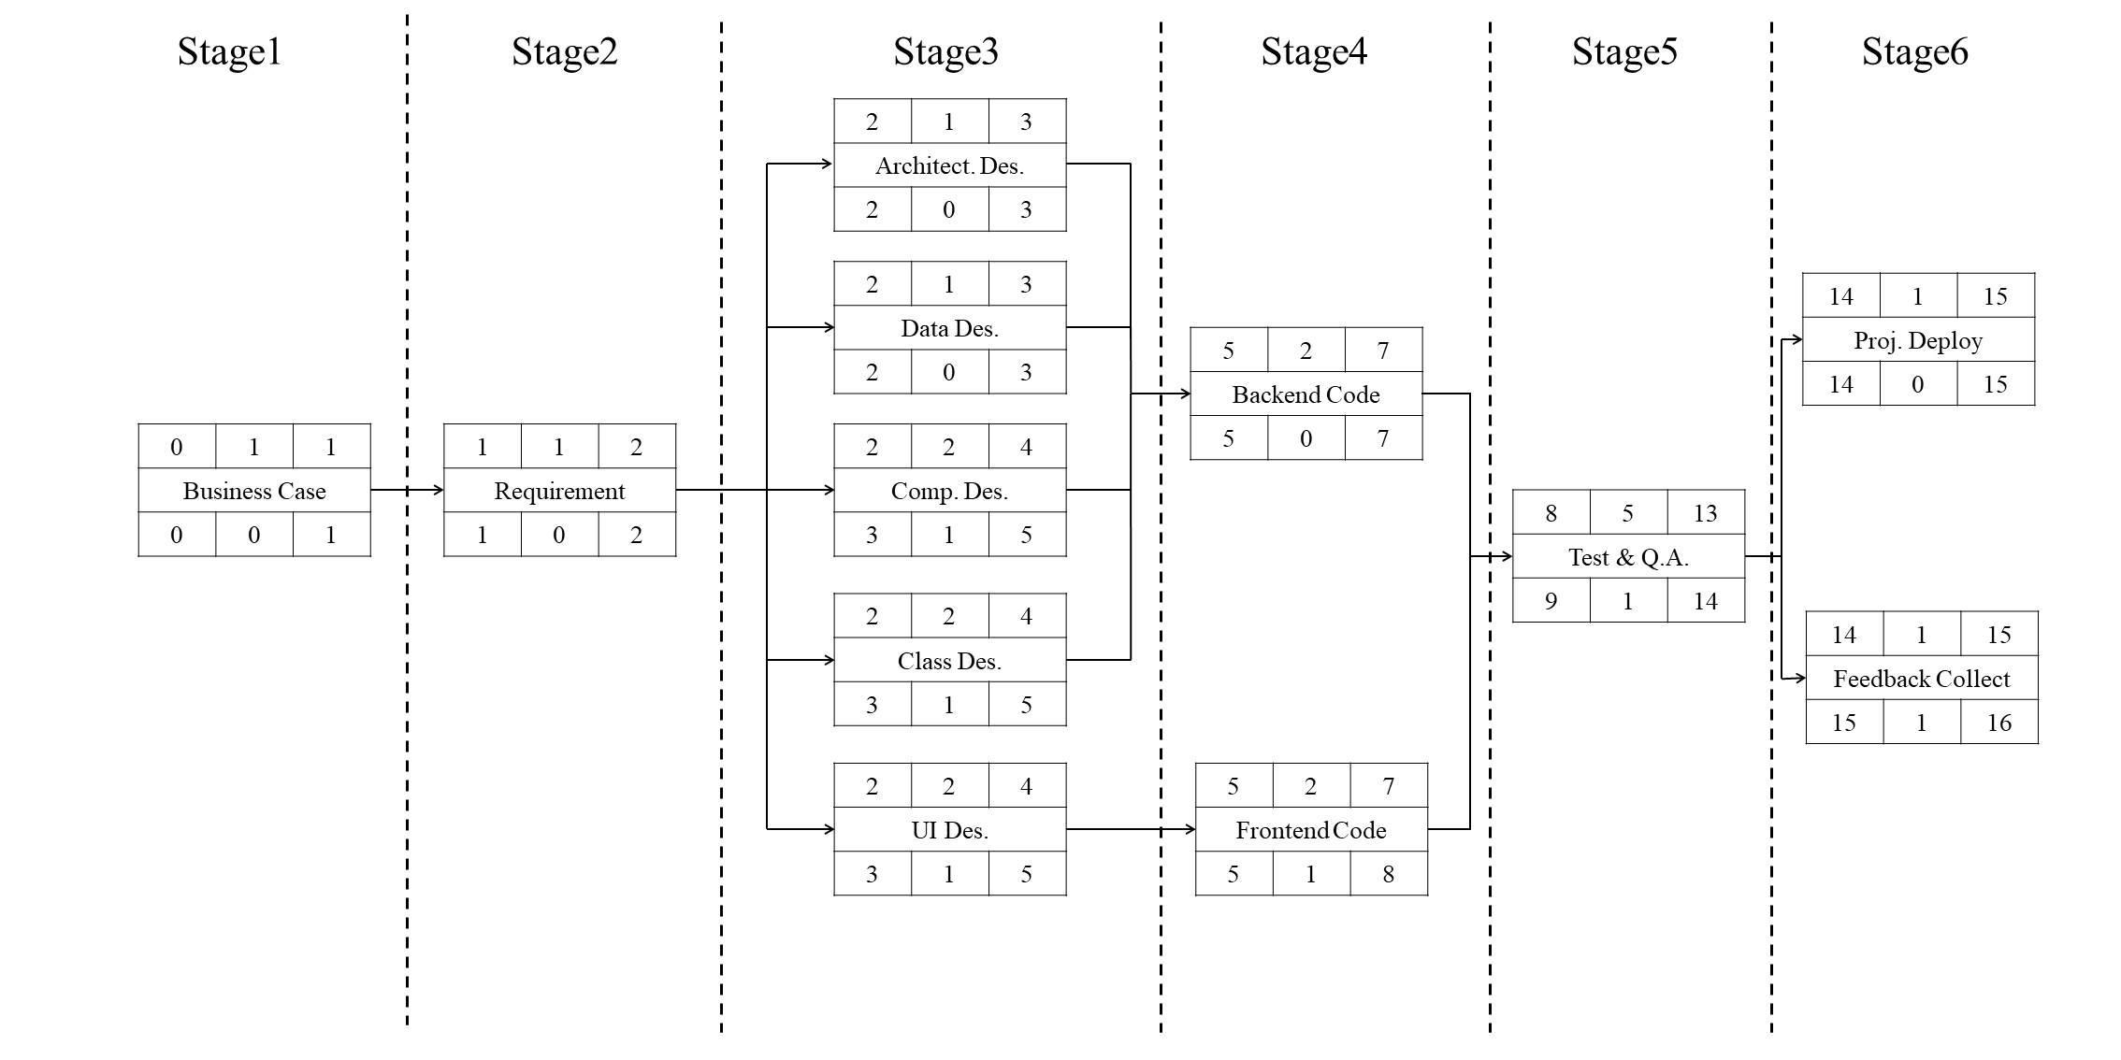

The resource needed in every stage shows in the following **Resource Requirement List**.

|  |  |  |  |  |
| --- | --- | --- | --- | --- |
| **Stage** | **Activities** | **Resource** | **Time** | **Details** |
| 1 | Business case analysis | PM  Business analyst | 1 week | Check business cases. |
| 2 | Requirement analysis | PM  Requirement analyst | 1 week | Analysis of use cases |
| 3 | Architecture design  Data design  Component design  Class design  Interface design | Architect  Team leader  Team member  Meeting room | 3 weeks | Mainly use Analyst/Designer |
| 4 | Backend coding  Frontend coding | Team leader  Team member  Laptops  Work tables & chairs  Meeting room | 3 weeks | most of materials and facilities |
| 5 | Quality Assurance | Tester  Team leader  Team member  Laptops  Work tables & chairs | 5 weeks | mainly test team |
| 6 | Project deployment  Feedback collecting | Team member  Server | 2 weeks | mainly develop team |

**5.3 Resource Scheduling**

The resource schedule shows the dates when each resource will be required and the degree of requirement. It will mainly consider human resource.

The following is the **resource histogram** exported by Gantt chart.

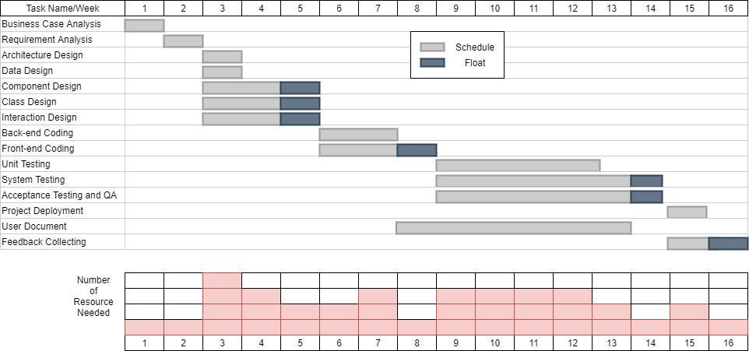

From the above we know every activity has been scheduled to start at its earliest start date, and we assign some float to it. But there is also a question: this scheduling method frequently creates **resource histograms** that start with a peak and then tail off, which is not equal.

So we can adjust the start date of some activities and split other, our **resource histogram** can be smoothed to contain resource demand at available levels. Updated smoothing resource histogram chart is shown below.

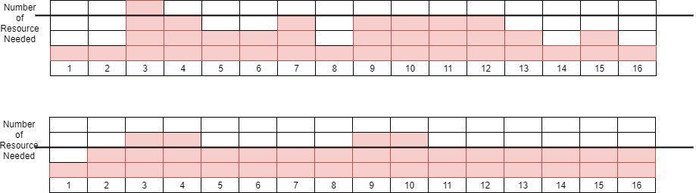

**6. Monitor and Control**

**6.1 Project control framework**

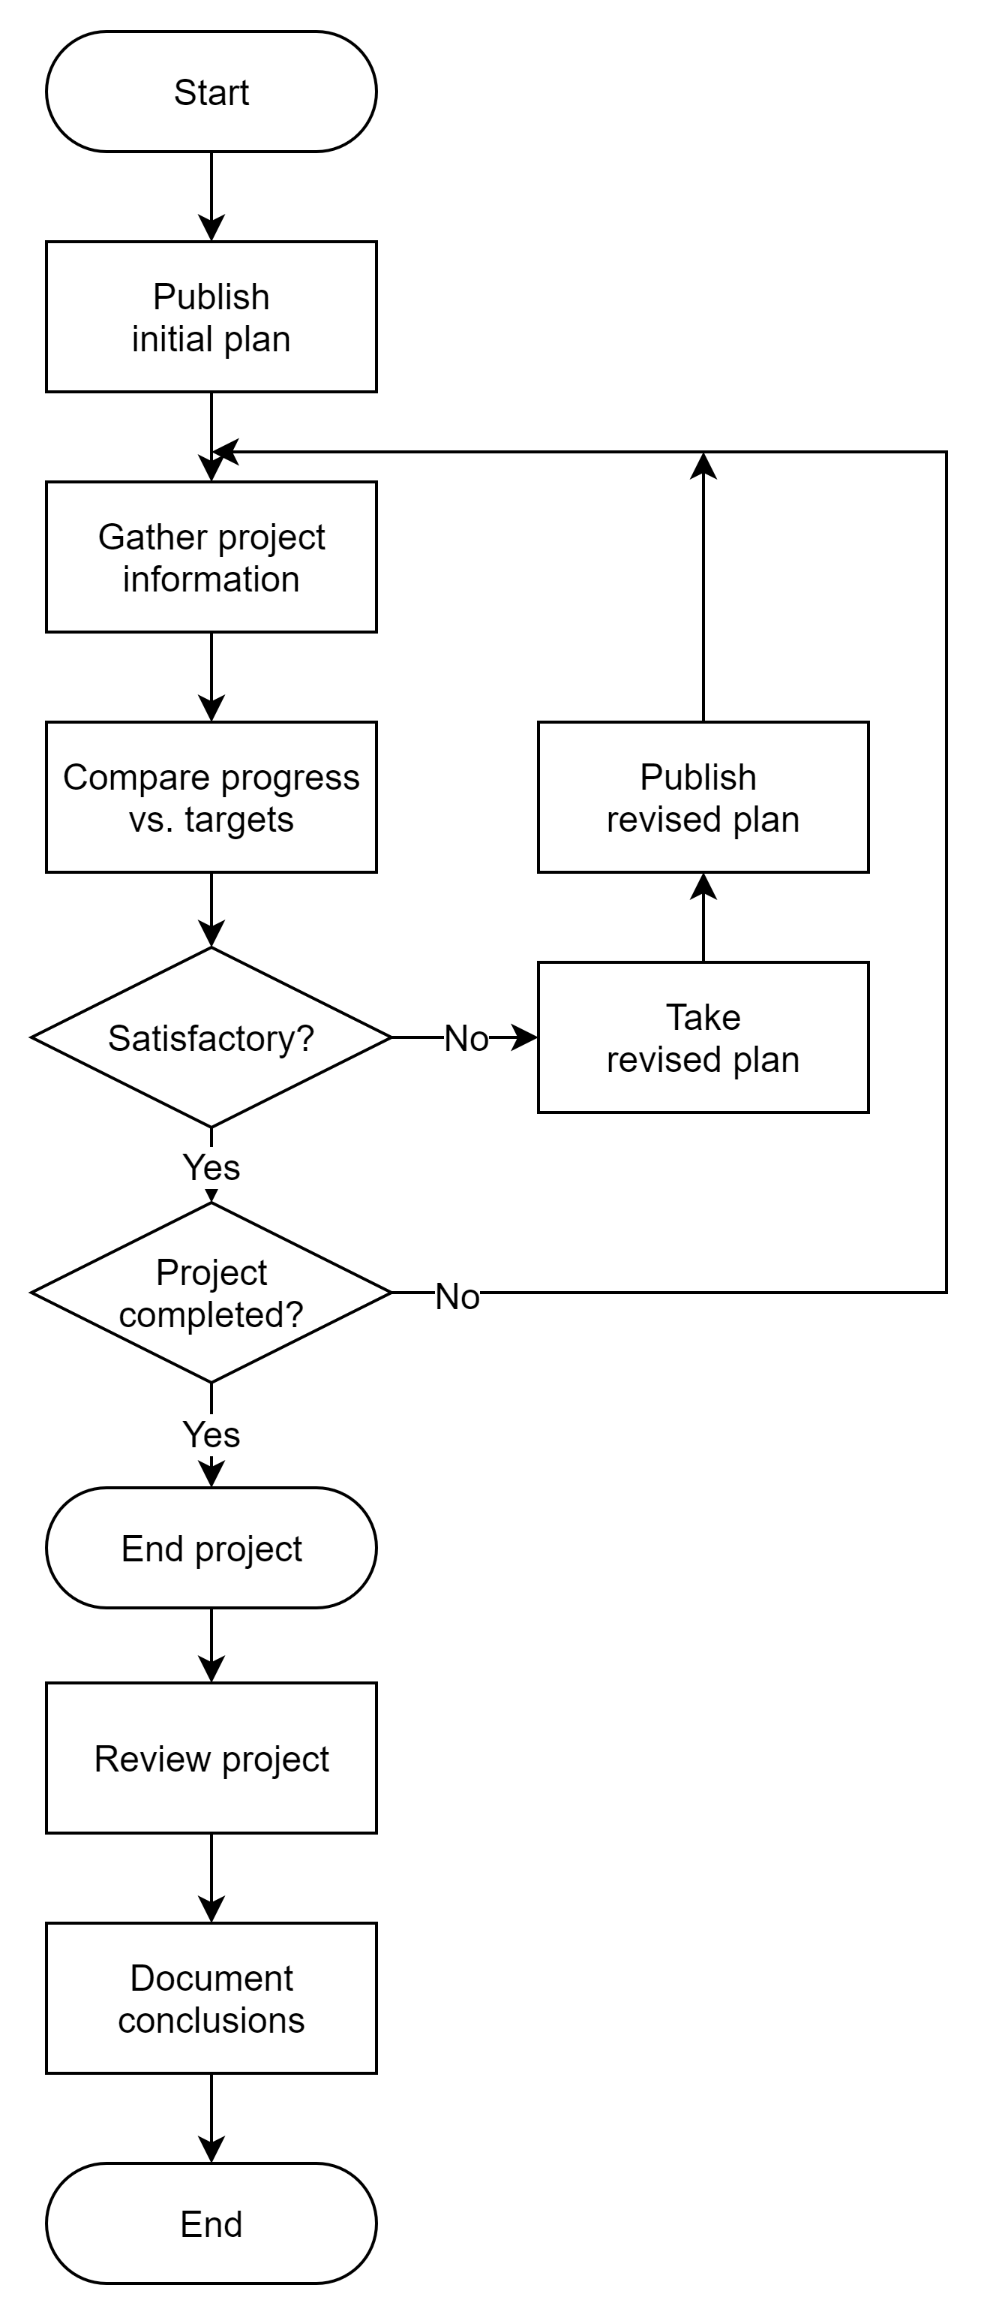

Controlling projects to ensure that their goals are met is a common monitoring problem, so that the actual situation can be ascertained and compared with current goals. If the actual situation does not match the plan, the plan needs to be reformulated to avoid deviation from the target, or the target needs to be changed. The above figure illustrates the project control cycle model, and illustrates that once the initial project plan is announced, the project control will be a process of continuously monitoring the progress according to the plan, considering deviations, and modifying the plan when necessary. The diagram also illustrates some important steps that must be taken after the project is completed, in order to apply the experience gained in any project to the planning stage of future projects and learn from past mistakes.

We monitor the progress of the project, compare the difference between the actual progress and the plan, and modify the plan so that the project can return to the expected track. The product manager in charge of the business pays attention to the progress of the project every day, and the project manager executes a project report once a week. Require hard-working team members to be effective, or allocate other resources to adjust the resources on the non-critical path to the critical path. Of course, other members of the team also need to provide reports in different ways and frequencies.

**6.2 Data Collection**

Everyone should collect partially completed tasks. In the process of collecting data, there are two methods: partial completion report and risk report. Considering that partial completion of the report will reduce the attention of employees and may cause delays, the task of partially completing the report is left to the product manager for production and analysis. Every employee must confirm the risk report once a week. The two reports are as follows. Since there is no actual process reference, the textbook has been appropriately modified to accommodate the sample report.

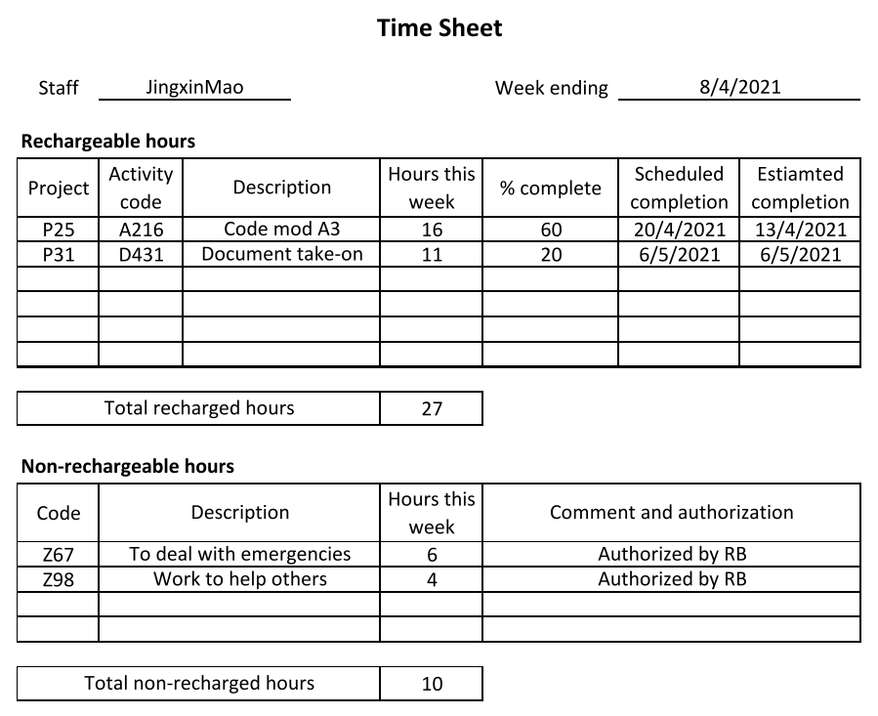

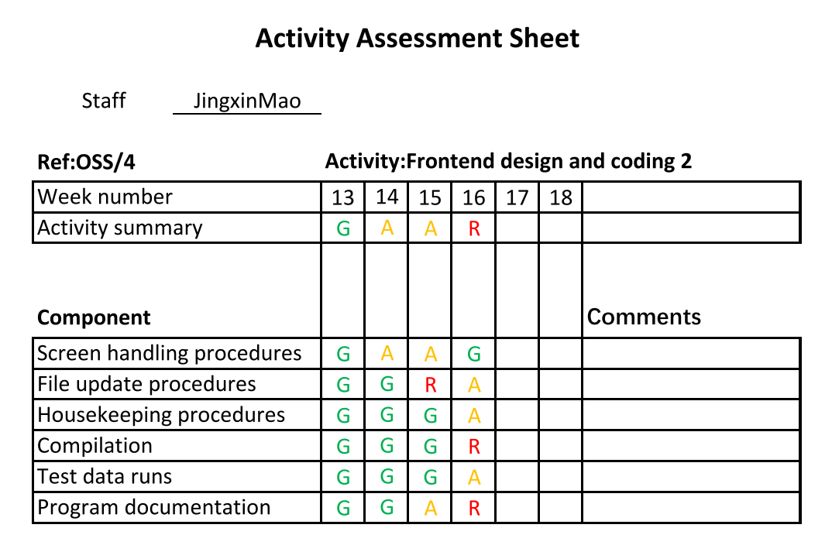

**6.3 Progress Visualization**

If data on the progress of the project is collected, the manager needs to use some method to present the best data. After the activity is completed, the project manager can modify the Gantt chart and should provide visual effects to all objects members. The figure below shows a Gantt chart of OSS.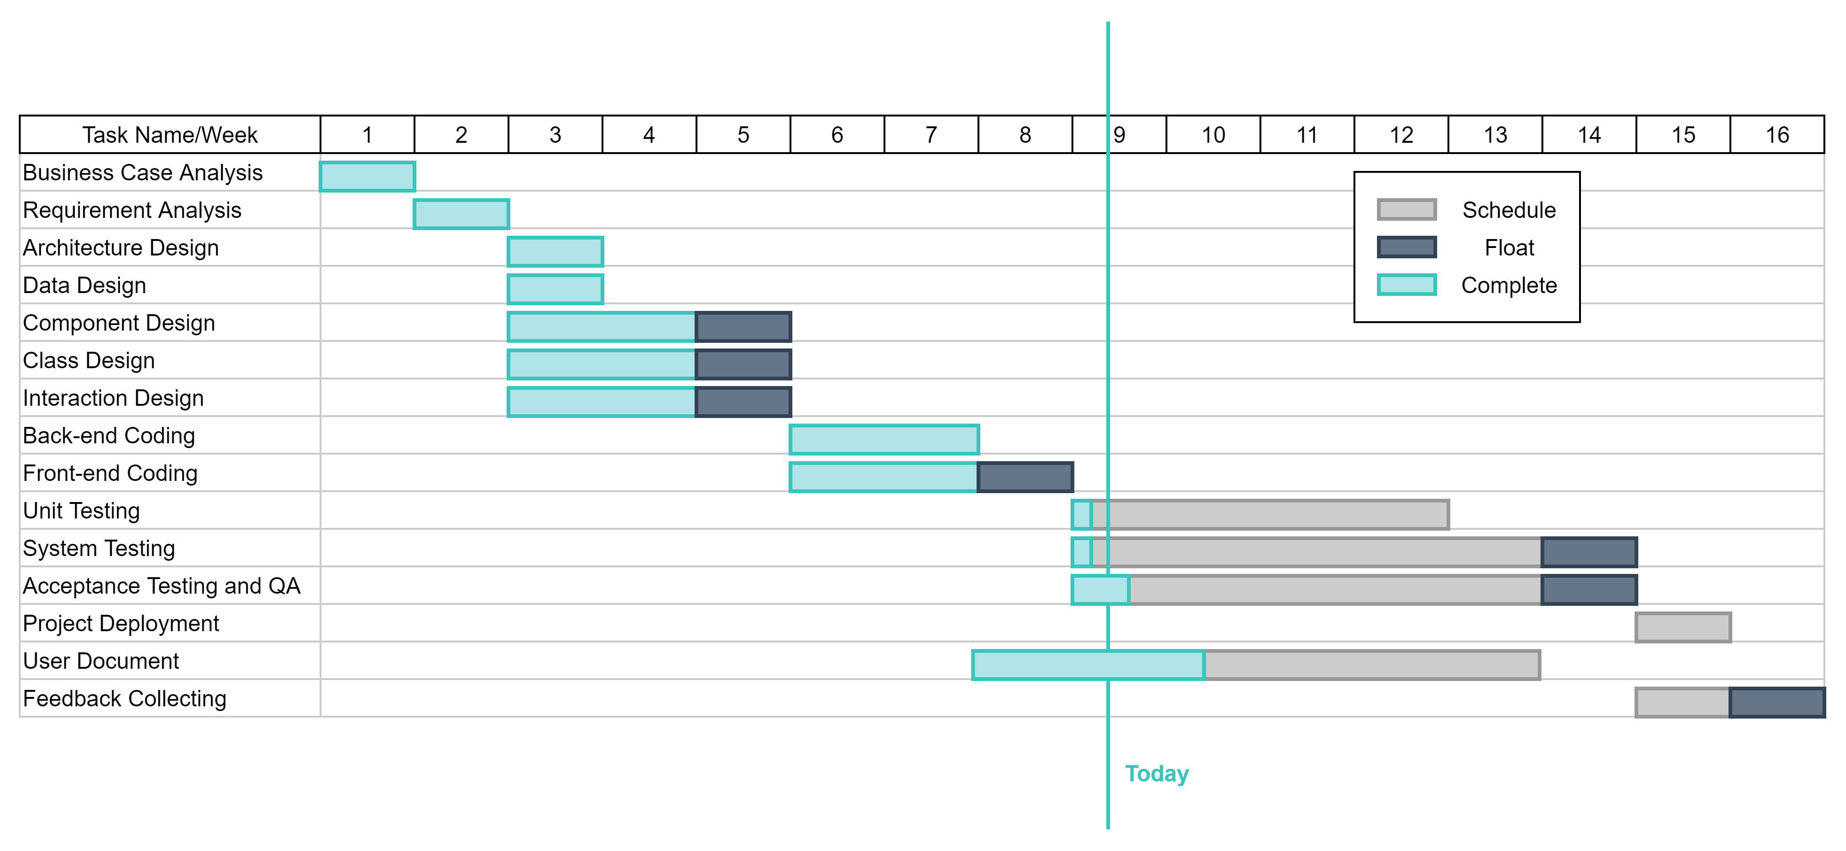

The delay diagram is another very similar diagram. This diagram provides more eye-catching visual indications for activities that are not progressing as planned: the more curved the delay line, the greater the deviation from the plan. The following figure shows a delay graph of OSS.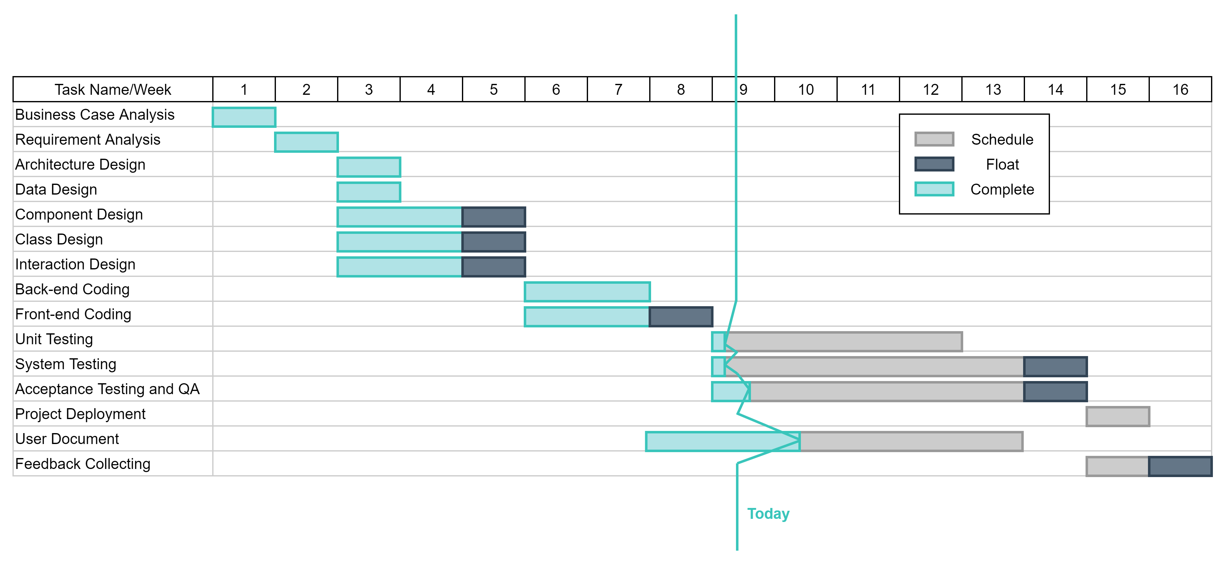

**6.4 Cost Monitoring**

Expenditure monitoring is an important part of project control. It indicates the effort we have made in the OSS project. Our OSS project may be completed on time, but this is because the money spent on activities exceeded the initial budget. Our cumulative expenditure table is shown below, which provides a simple way to compare actual expenditures and planned expenditures. In addition, before attempting to explain the meaning of recorded expenditures, we also need to consider the current status of OSS project activities.

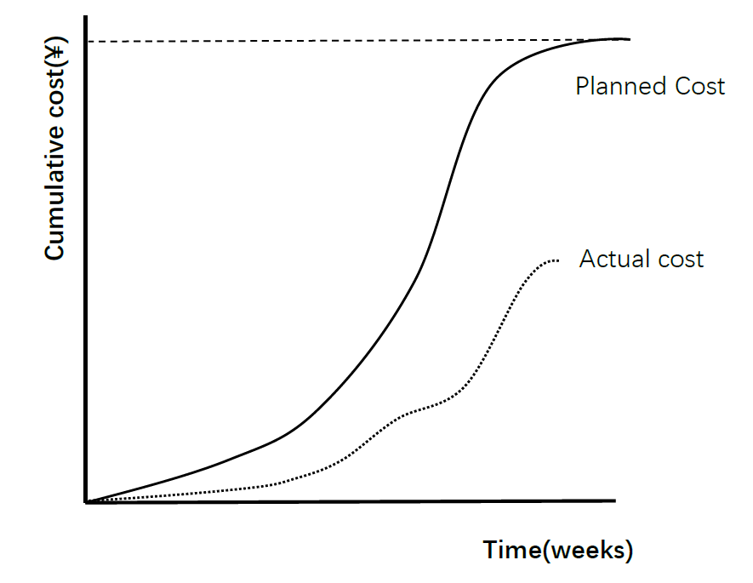

If you add planned future costs to the graph, the cost curve graph will be more useful. By adding the estimated cost of unfinished work to the cost already paid, the estimated future cost can be derived. Where computer-based planning tools are used, under normal circumstances, once the actual cost is recorded, the revision of the cost schedule is automatically given. The figure below illustrates that additional information is available once the revised cost schedule is included (if so, obviously the project has been delayed and exceeded the budget).

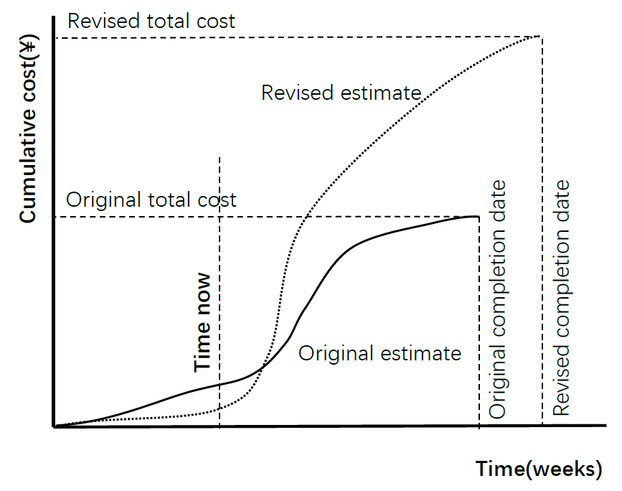

**6.5 Earned Value Analysis**

* **Plan Value (PV, Plan Value)：** Budgeted cost for planned workload (**BCWS**, Budgeted Cost for Work Scheduled). Refers to the budgeted man-hours (or expenses) required for the amount of work required to be completed in a certain stage of the project implementation process. The calculation formula is:
  + **PV = BCWS = planned workload × planned unit price**
  + PV mainly reflects the amount of work that should be completed in the schedule, rather than reflecting the man-hours or expenses that should be consumed.
* **Actual cost (AC, Actual Cost)：** Actual cost of completed work (**ACWP**, Actual Cost for Work Performed). Refers to the man-hours (or expenses) consumed in the actual completion of the workload at a certain stage of the project implementation process, and is the actual consumption indicator for project implementation. The calculation formula is:
  + **AC = ACWP = Work completed × actual unit price**
* **Earned Value (EV, Earned Value)：**Budgeted Cost for Work Performed (**BCWP**, Budgeted Cost for Work Performed). Refers to the actual amount of work completed at a certain stage of the project implementation process and the working hours (or expenses) calculated according to the budget quota. The calculation formula is:
  + **EV = BCWP = completed work × planned unit price**
* Combining these three values can determine whether the work is completed as planned at that point in time. The most commonly used metric is cost variance:
  + Cost variance(**CV**) ：
    - **CV = EV – AC**
    - A negative CV means over cost.
  + Schedule variance(**SV**)：
    - **SV = EV – PV**
    - A negative SV means behind schedule.
  + Time variance(**TV**)：
    - difference between EV time and now.
* For performance ratios, we generally track two ratios.
  + **CPI**(Cost Performance Index) = EV / AC
  + **SPI**(Schedule Performance Index) = EV / PV

The performance ratio can be regarded as a kind of "monetary value" index. If the value is greater than 1, it means that the completed work is better than planned. If the value is less than 1, it means that the cost of work is greater than expected and/or The work progressed more slowly than planned.

We combine the **Baseline Budget** and **0/100 technology**, assign 0 to unfinished tasks, and 100% to tasks that have completed the budget.

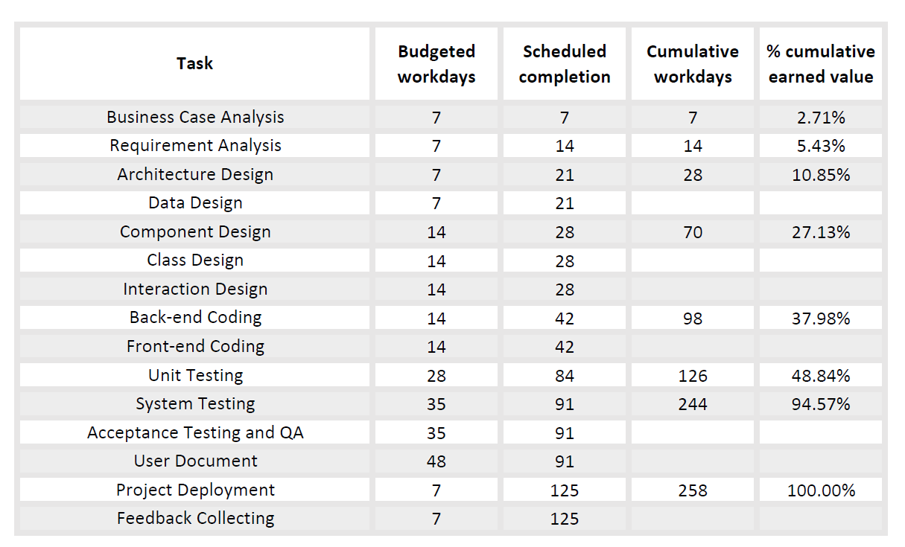

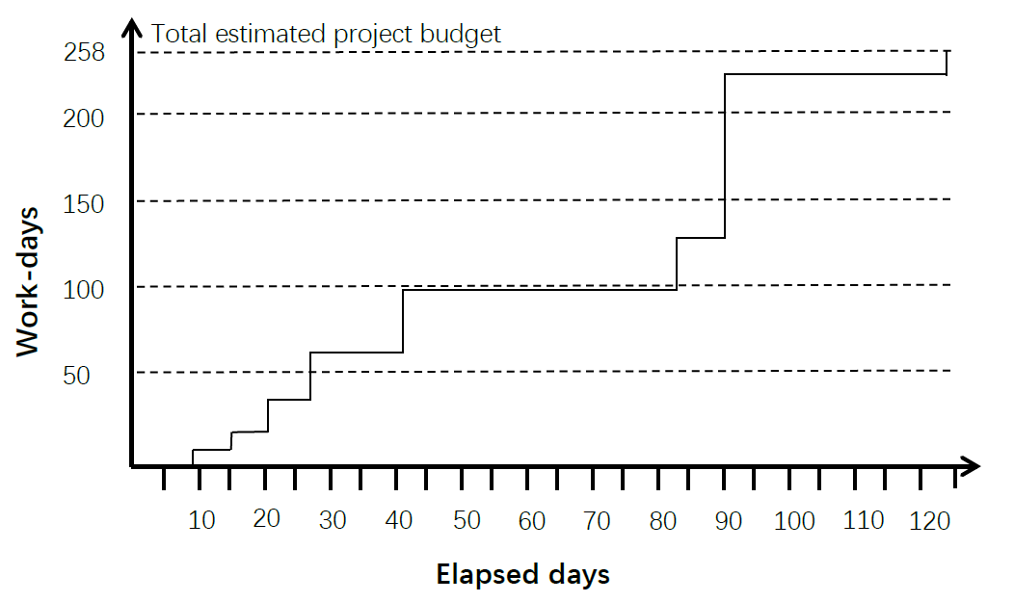

**6.6 Change Control**

Because changes including requirements changes and personnel changes cannot be avoided in the software management process, we must control and manage changes. The change control management process is shown in the figure below:

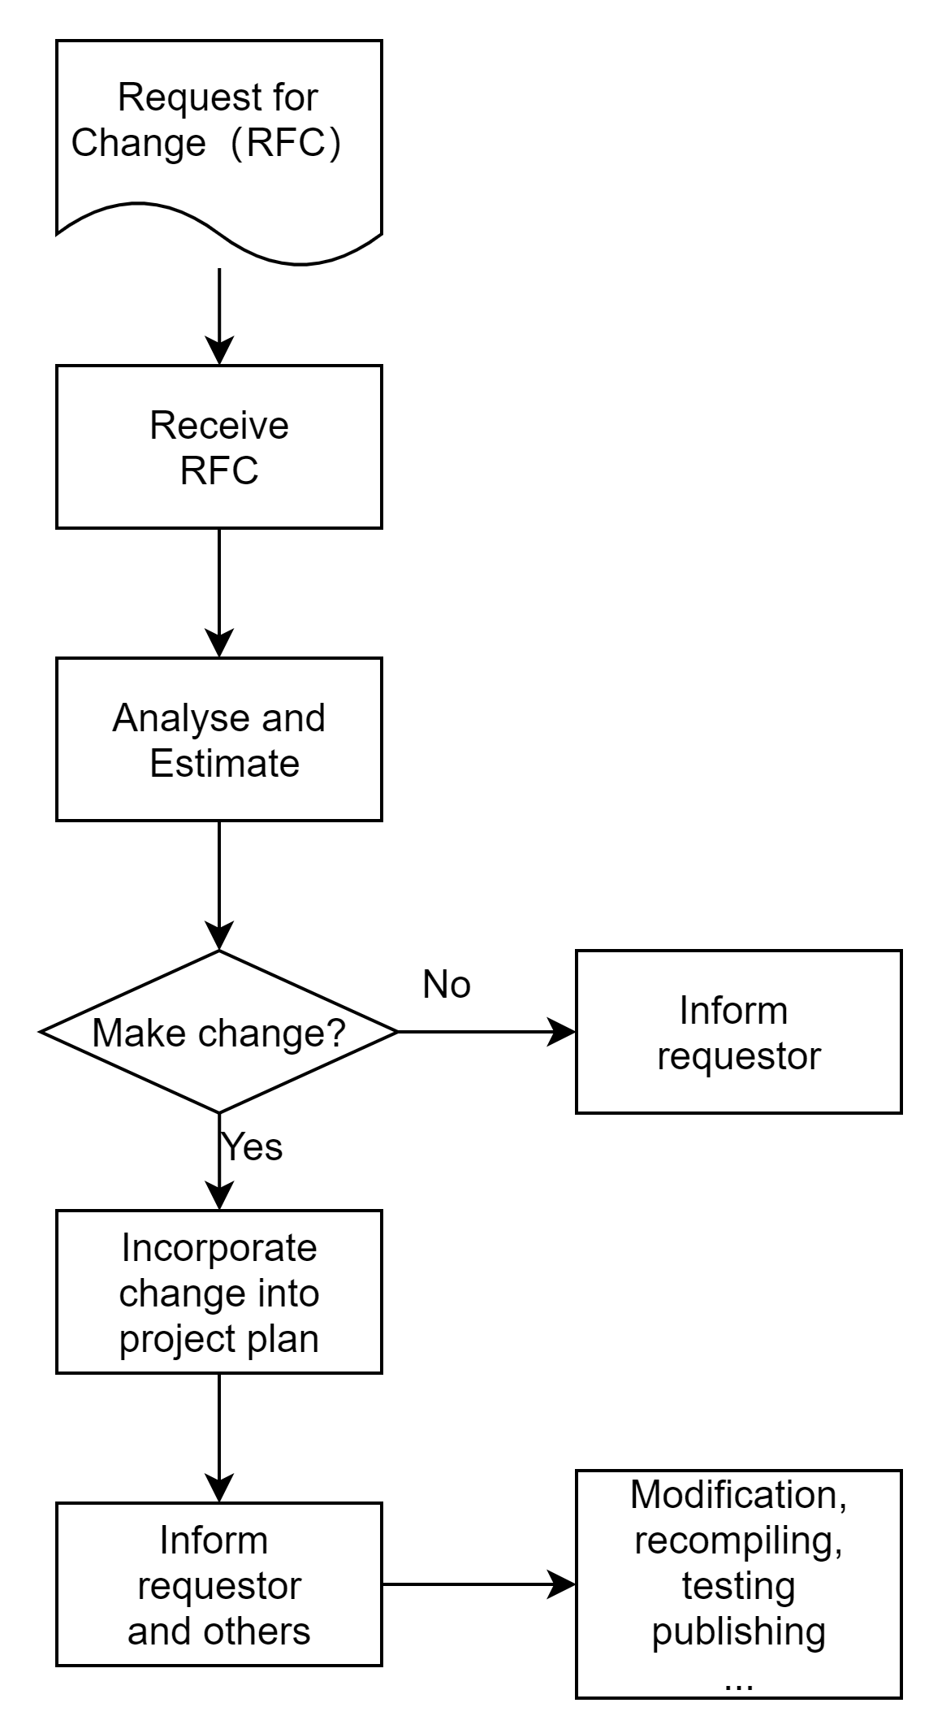

The most important is to plan the change in advance, and then we estimate the risk of controlling the change and include successful verification. The change must be tested to ensure that we can control the change. Finally, we assign employees to take on new responsibilities to solve the problems caused by the change.

**7. Project Implementation**

**7.1 Process Model**

**Incremental model**

The incremental model is a synthesis of the waterfall model and the prototype evolution model. Its consideration of the software process is: as a whole, implement project development in accordance with the waterfall model process to facilitate project management; but in the actual creation of the software, it will The software system is decomposed into many incremental components according to functions, and the components are created and delivered one by one until all the incremental components are created and integrated into the system and delivered to users.

Each member of the team plays different roles in incremental development.

|  |  |  |
| --- | --- | --- |
| **Role** | **Name** | **Responsibility and Tasks** |
| Sponsor  (Client or Project Owner) | All of us play the role. | 1. Control the determination of the functional requirement of the project.  2. For each development increment, adjust requirement according to actual situation if needed.  3. Check work process with the development team. |
| Development Team Leader | Mao Jingxin | 1. Be responsible for monitoring and controlling the progress of the project.  2. Communicate between team and sponsor, link them together.  3. Construct good communication and collaboration between members. Try to avoid or solve obstacles in team as possible |
| Development Team Member | Huang Yiou, Chen Yangsen, Mao Jingxin, Tan Zhongyu | 1. Be responsible for the coding and deployment of the project.  2. Report own process on time.  3. Participate in team meeting and communicate to get best team cooperation. |

Meetings are an important part of incremental development. During the meeting, the product owner informs the development team of the feedback on the previous increments and the newly generated increments to be developed. He needs to decide which existing increments to modify and which new ones to develop. The development team decided that they could guarantee the completion of several sub-items before the next incremental delivery.

The following is a list of the types of meetings we have held:

|  |  |
| --- | --- |
| **Meeting** | **Time and Task** |
| **Planning Meeting** | Every Saturday at 14:00. Arrange next week's task Daily Meeting |
| **Retrospective Meeting** | Every Saturday at 14:00, review last week's accomplishments before the planning meeting and dynamically adjust the tasks for the next week |

**7.2 Development Techniques**

* Development Tools

|  |  |  |
| --- | --- | --- |
| **Tool** | **Illustration** | **Offical Web** |
| **Microsoft Visual Studio 2019** | IDE | <https://www.microsoftstore.com.cn/software/visual-studio> |
| **Visual Studio Code** | IDE | <https://code.visualstudio.com/> |
| **MySQL Workbench 8.0.23** | Database design tool | <https://dev.mysql.com/downloads/workbench/> |
| **AliYun** | Deployment platform | <https://cn.aliyun.com/> |

* Development Environment

|  |  |  |
| --- | --- | --- |
| **Environment** | **Version** | **Download Url** |
| **ASP.NET MVC** | 3 | <https://dotnet.microsoft.com/apps/aspnet> |
| **Mysql** | 5.7.30-winx64 | [https://downloads.mysql.](https://downloads.mysql.com/archives/community/)  [com/archives/community/](https://downloads.mysql.com/archives/community/) |

* Design Elements

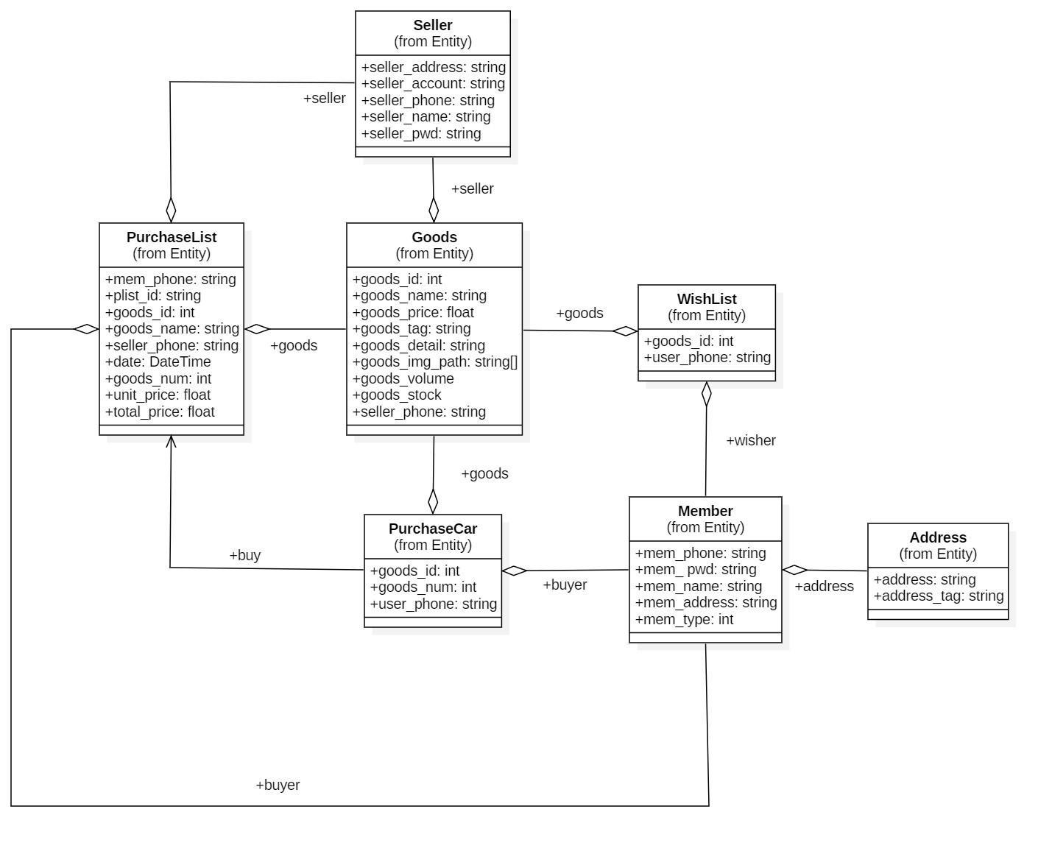

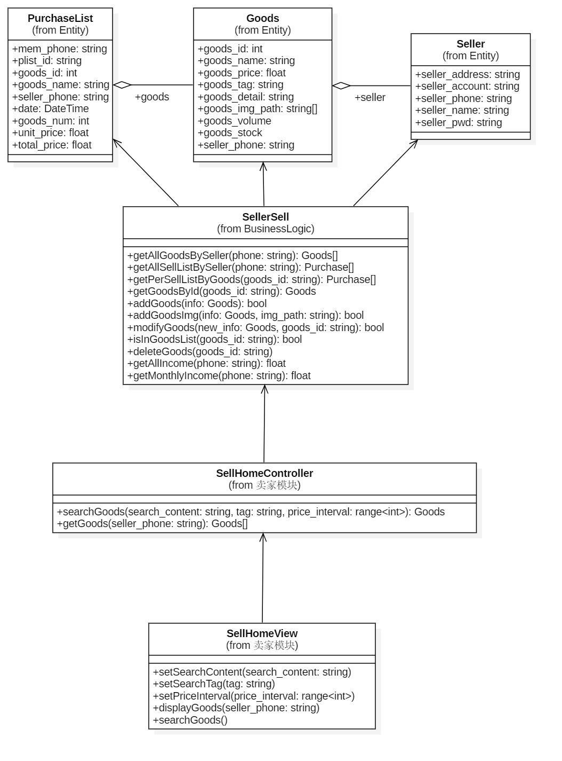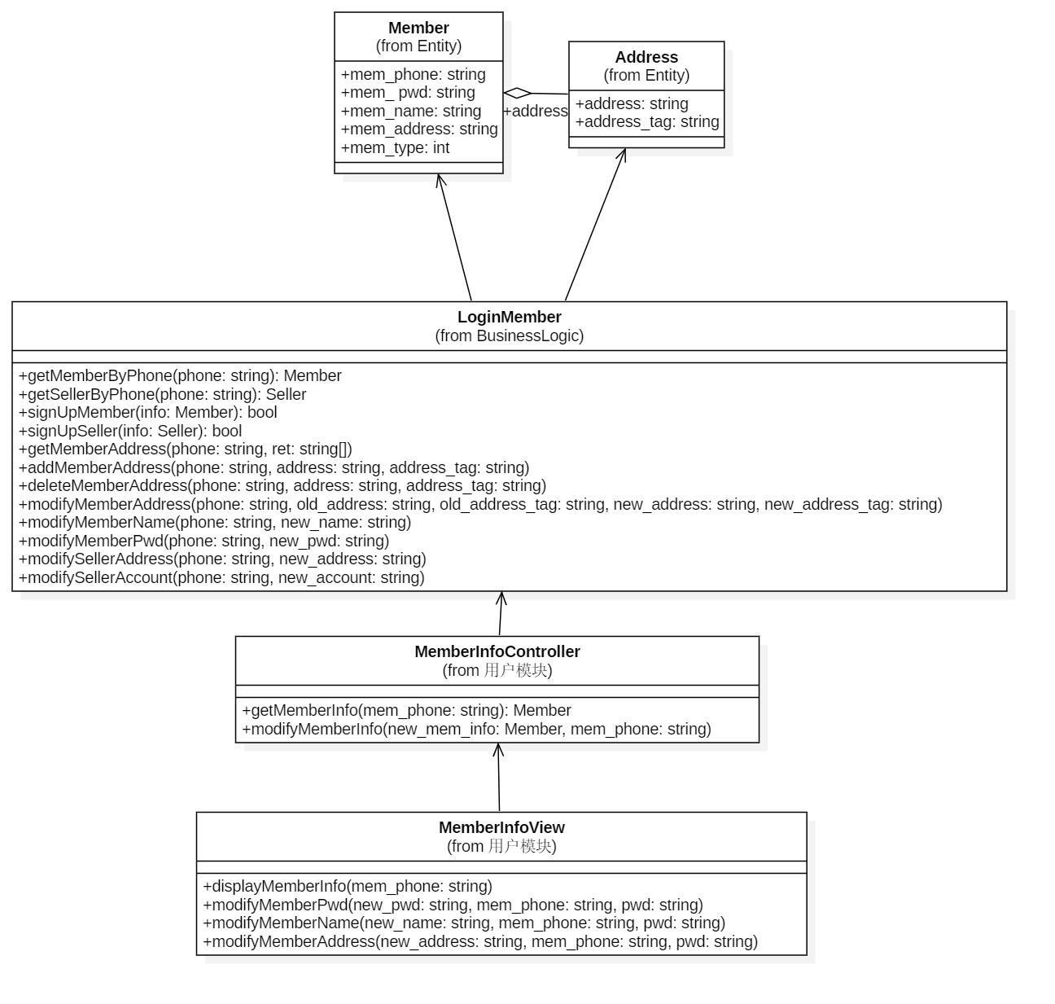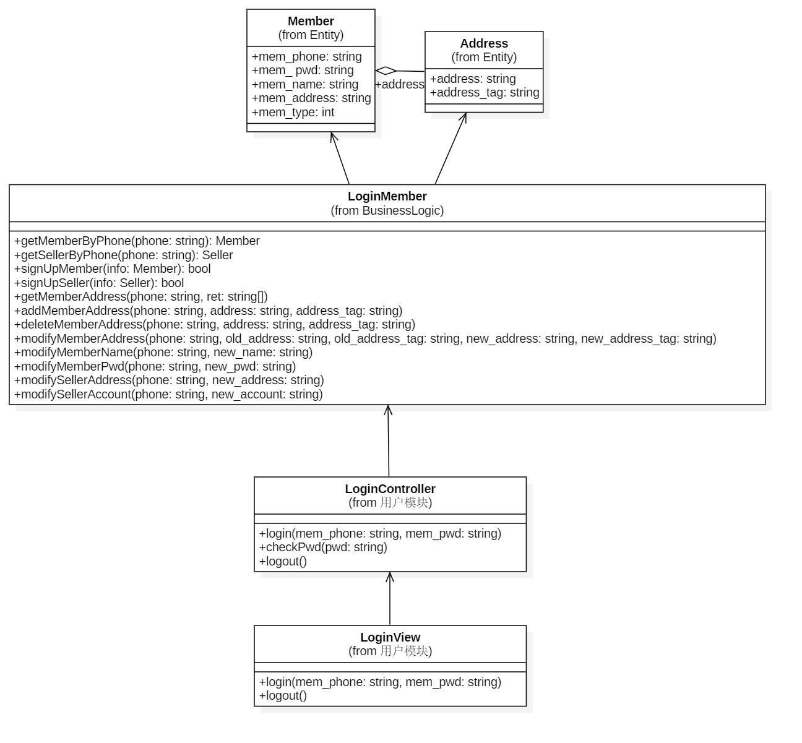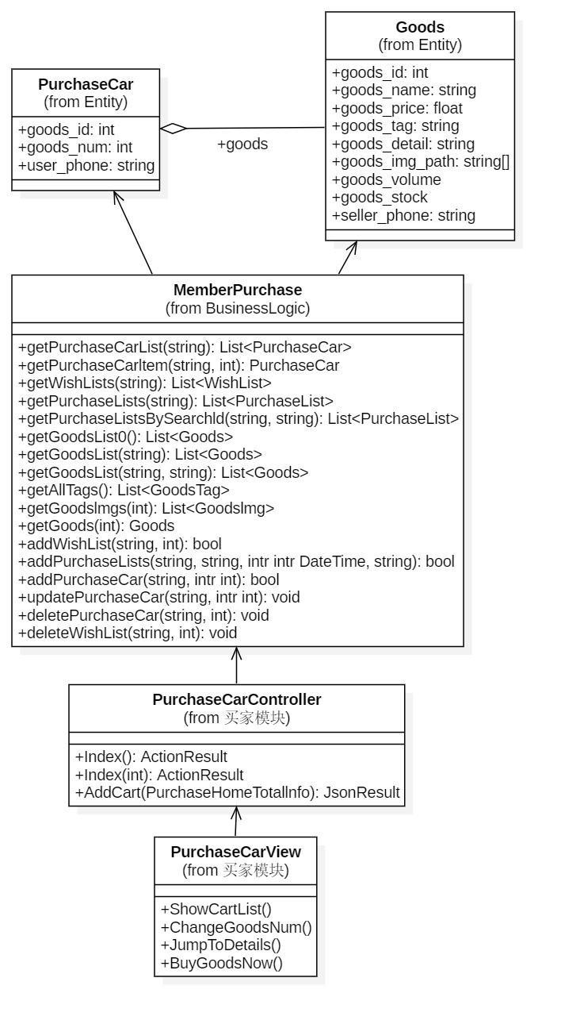

* Deployment Diagram

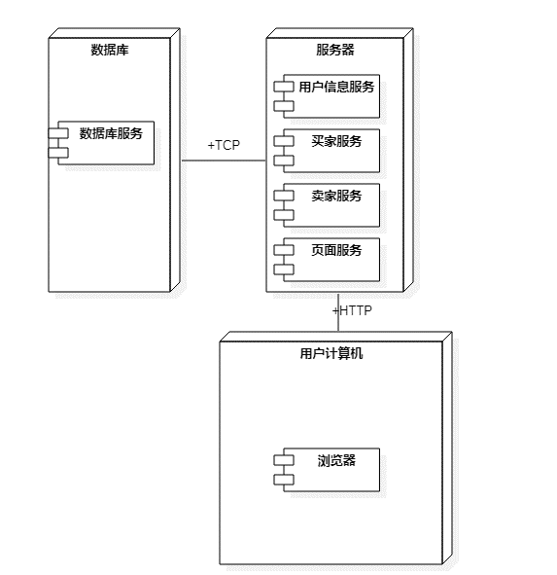

* Design Architecture

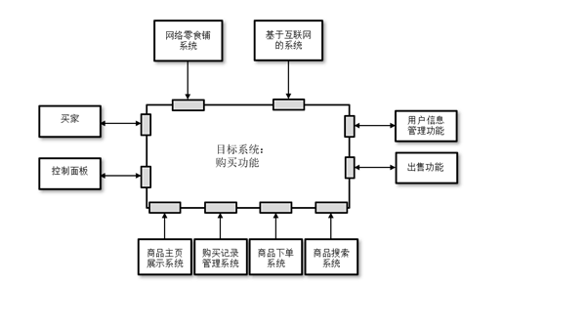

**8. Prototype**

**8.1 Registration interface**

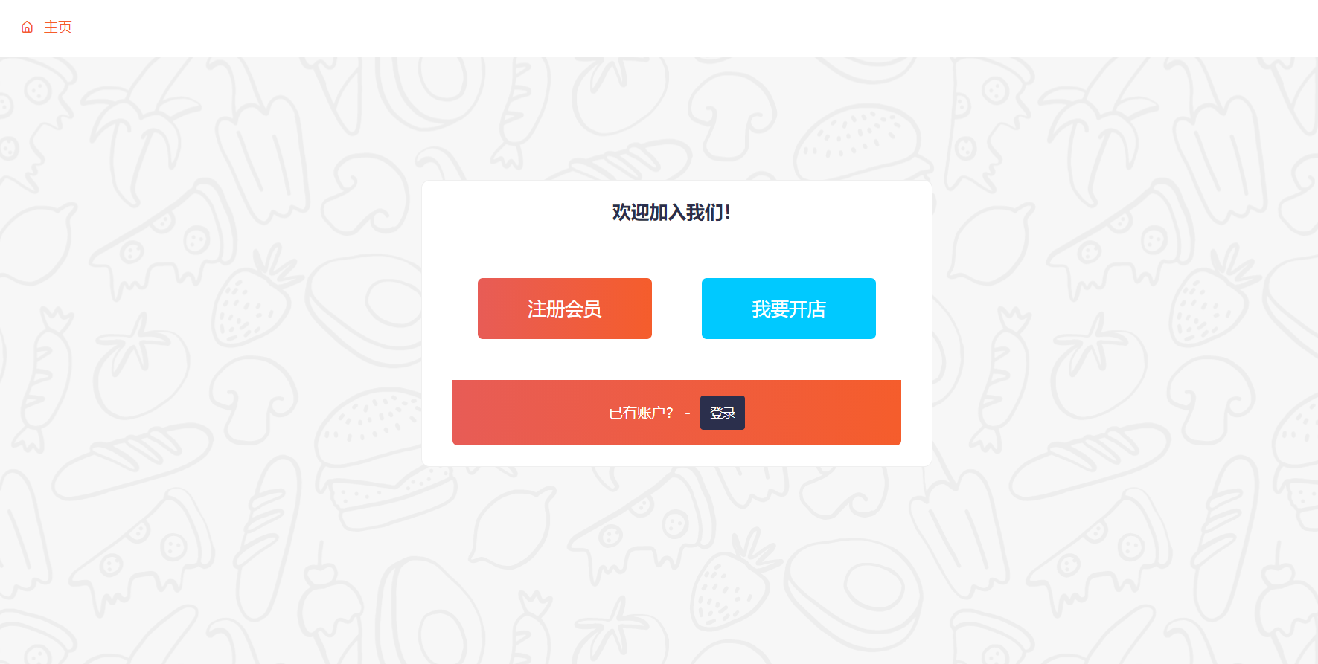

Figure 8.1.1

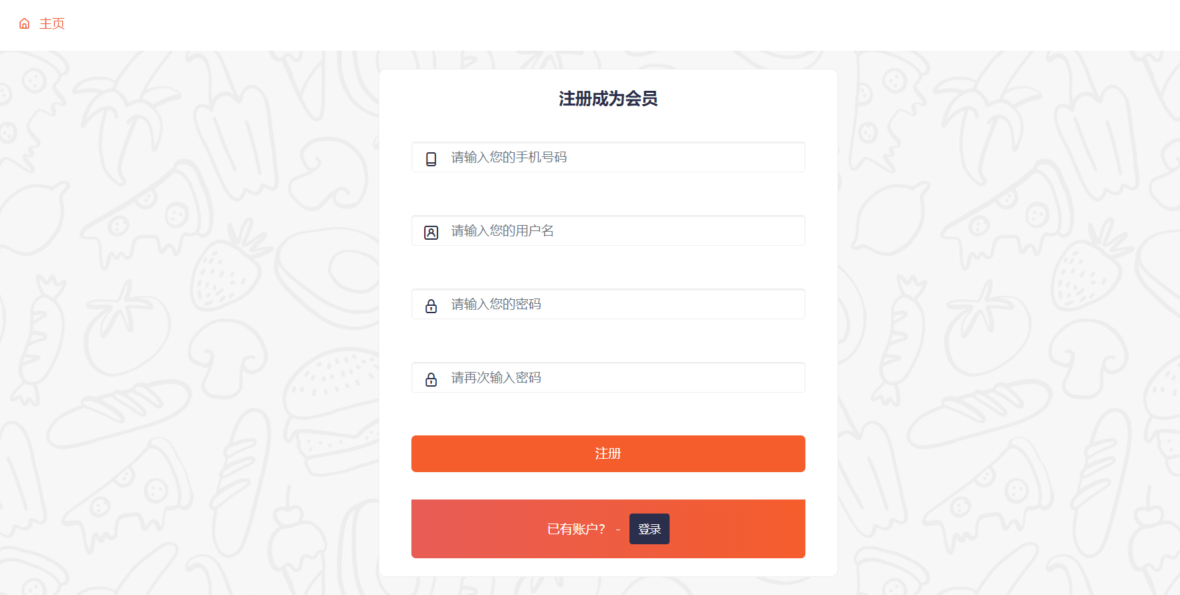

Figure 8.1.2

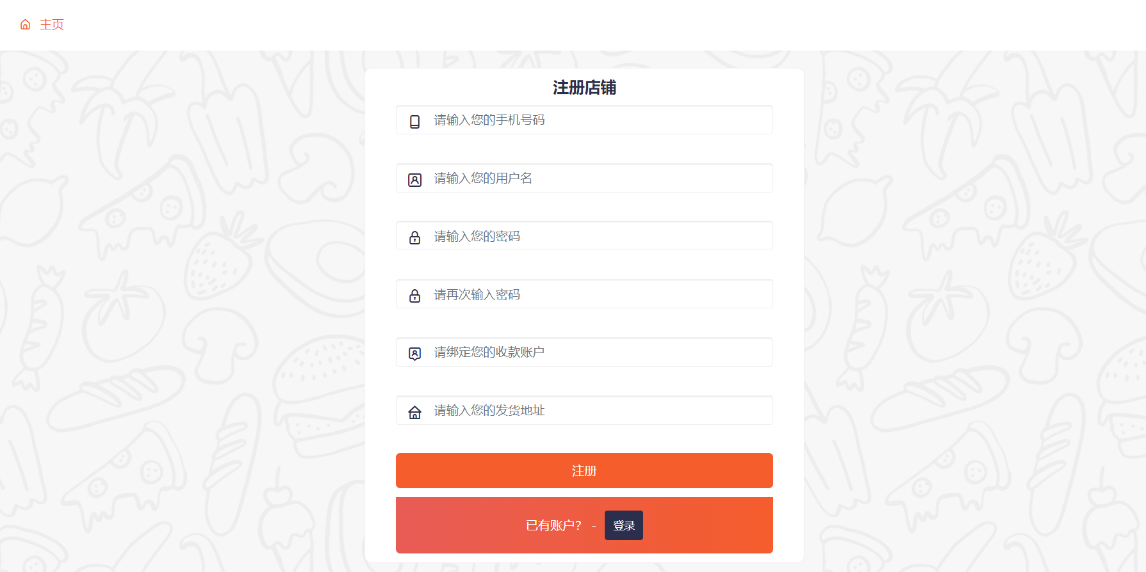

Figure 8.1.3

When visiting this website, users can choose to register as an official user (8.1.1) of this website, that is, choose to register as a buyer (Figure 8.1.2) and a seller (Figure 8.1.3). To register as a buyer, you can use the shopping cart on this website, check purchase records, add wishlists, add or change the delivery address, etc., and register as a seller directly, not only will you automatically become a buyer, but you can also add and drop products and check sales. Record, conduct flow query and other operations.

**8.2 HomePage**

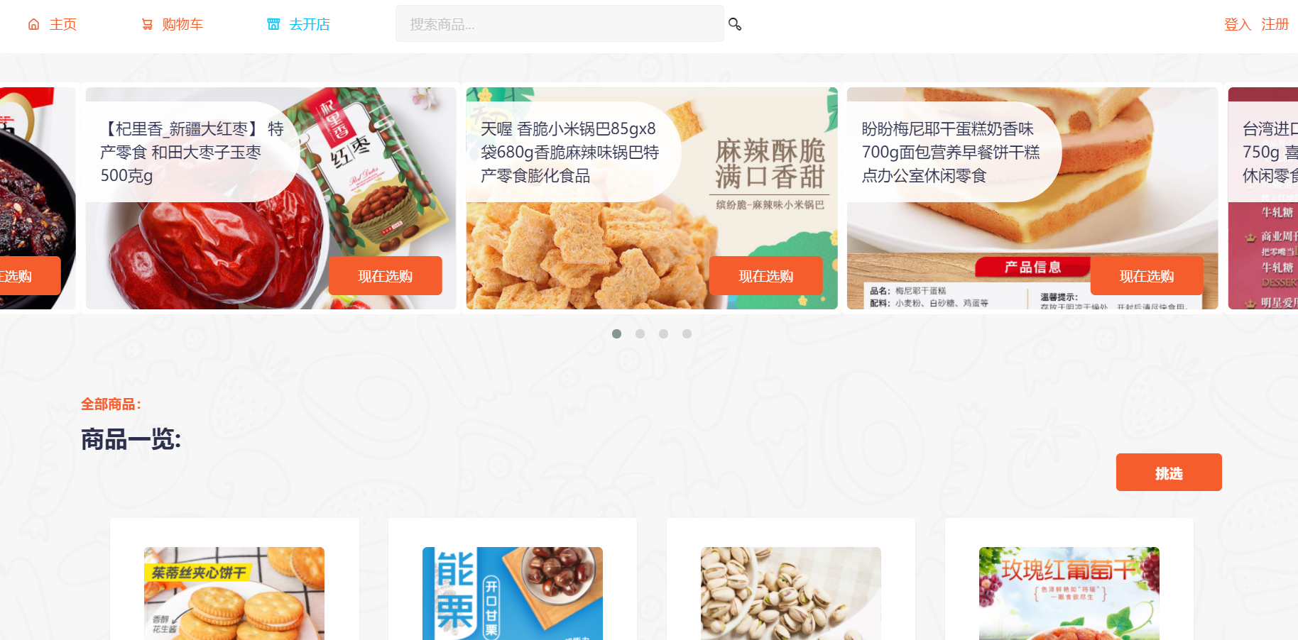

Figure 8.2.1

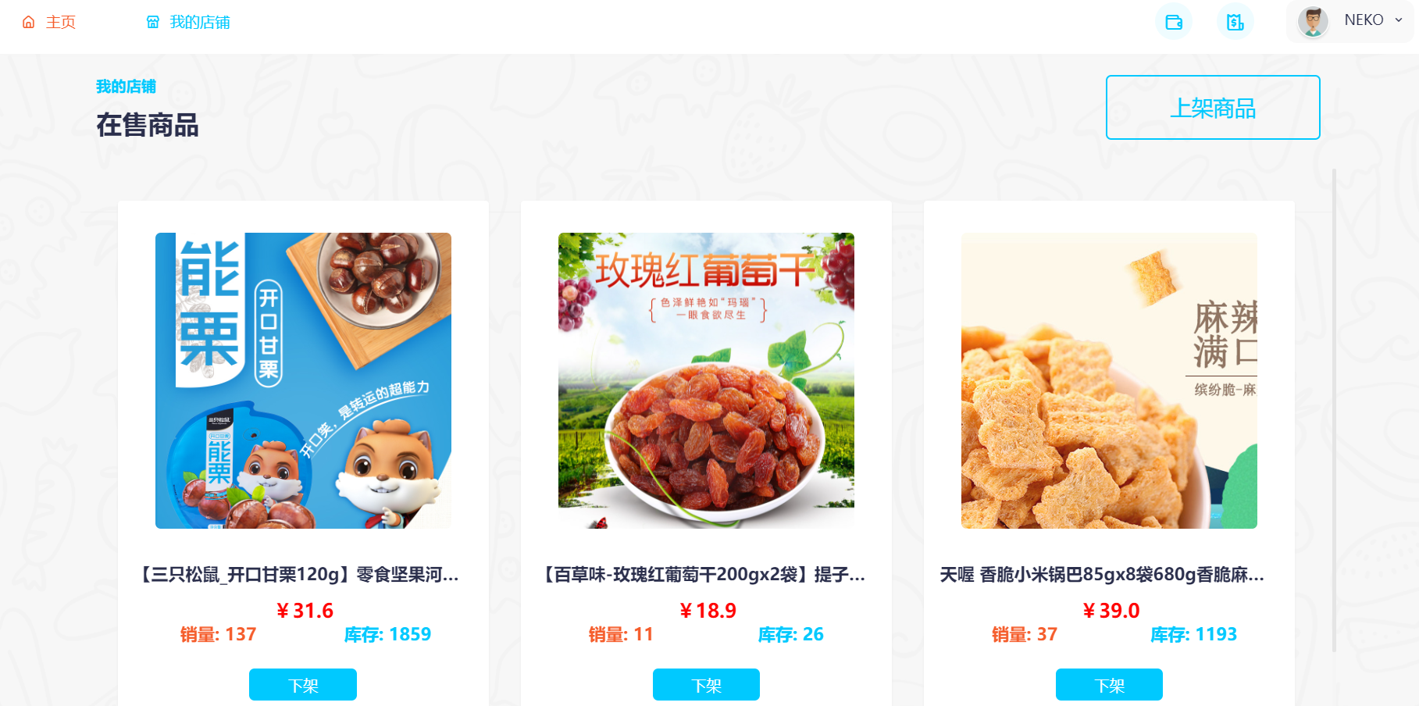

Figure 8.2.2

The homepage of the website is mainly composed of two modes: the buyer homepage (Figure 8.2.1) and the seller homepage (Figure 8.2.2). The buyer homepage can perform operations such as product purchase, fast classification of products, and product search, and the seller homepage can perform operations Commodity on and off shelves, replenish inventory, increase product pictures and other functions

**8.3 Product details page**

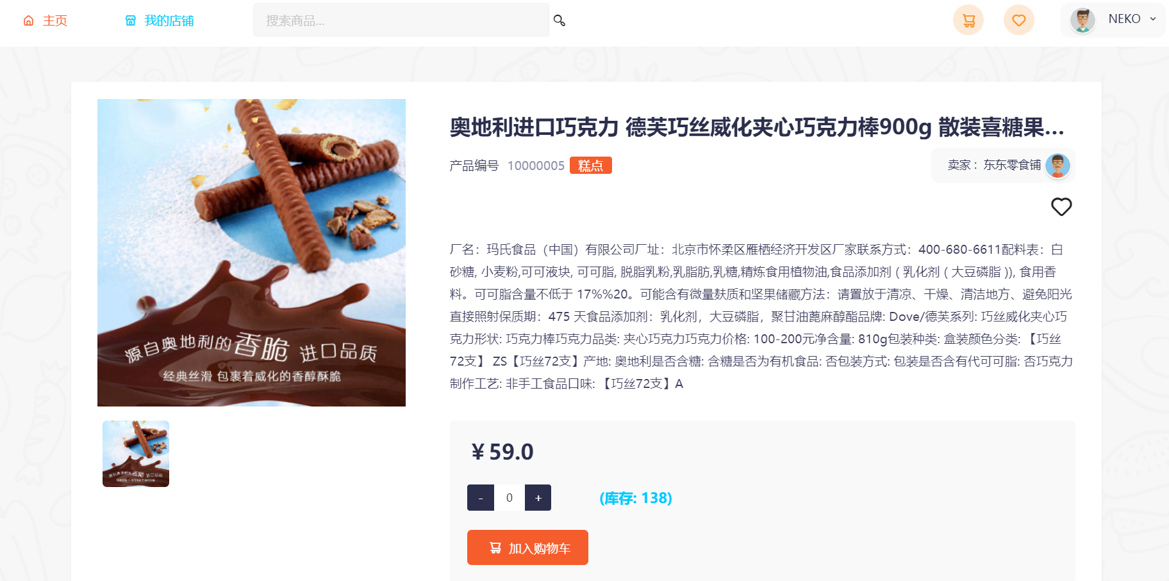

Figure 8.3.1

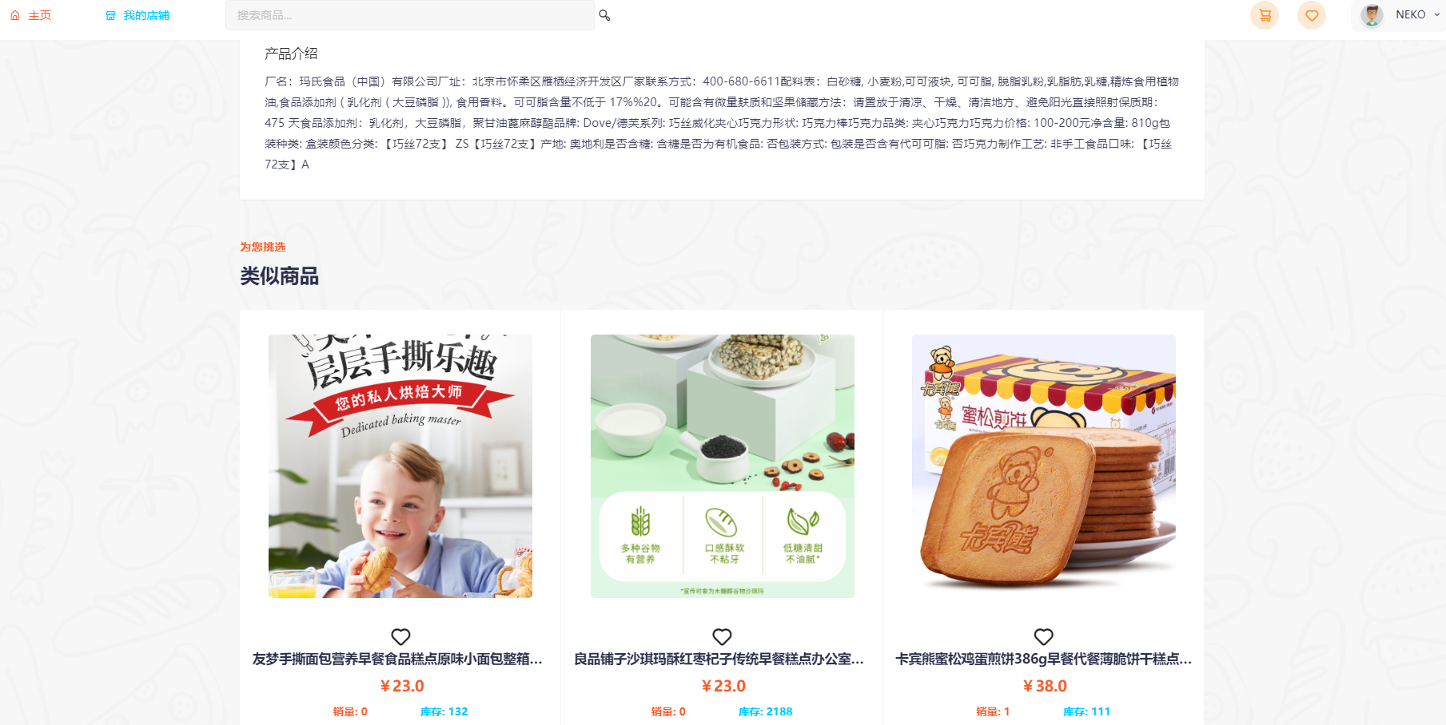

Figure 8.3.2

The product detail page (Figure 8.3.1) is used to display the detailed content of a single product in detail, including the product detail page, serial number, seller information, sales and inventory, and other information. It also includes similar recommendations for related products (Figure 8.3.2) )

**8.4 PurchaseCar**

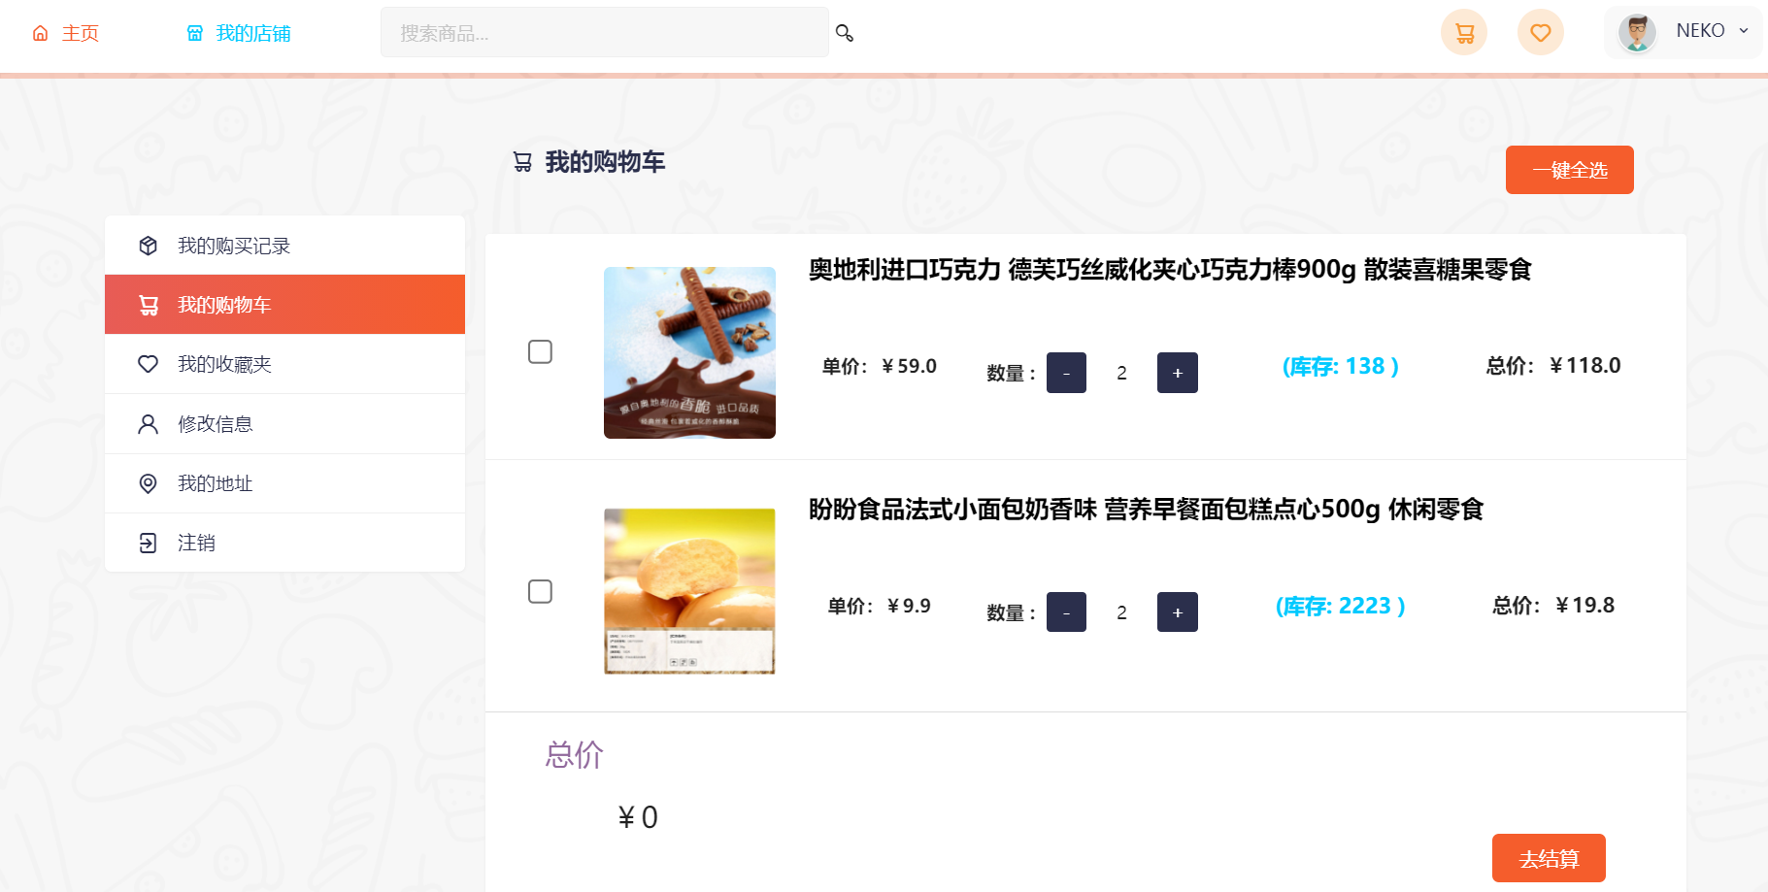

Figure 8.4.1

The shopping cart page (Figure 8.4.1) is used to display the current buyer’s shopping cart. Buyers can filter products for purchase here

**8.5 Purchase and payment**

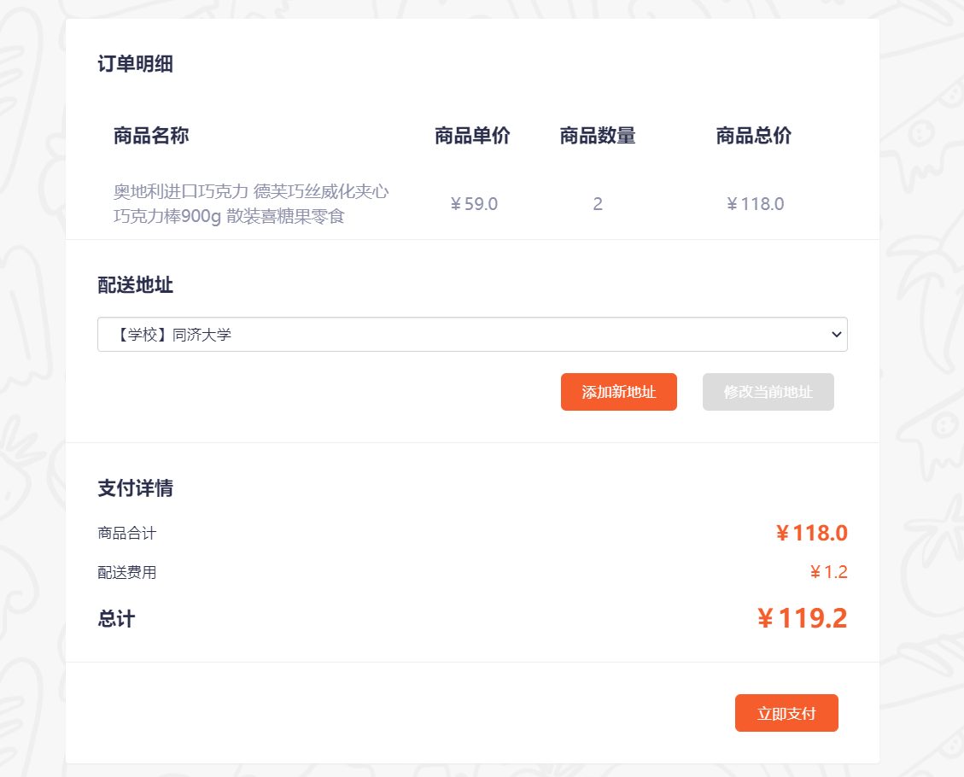

Figure 8.5.1

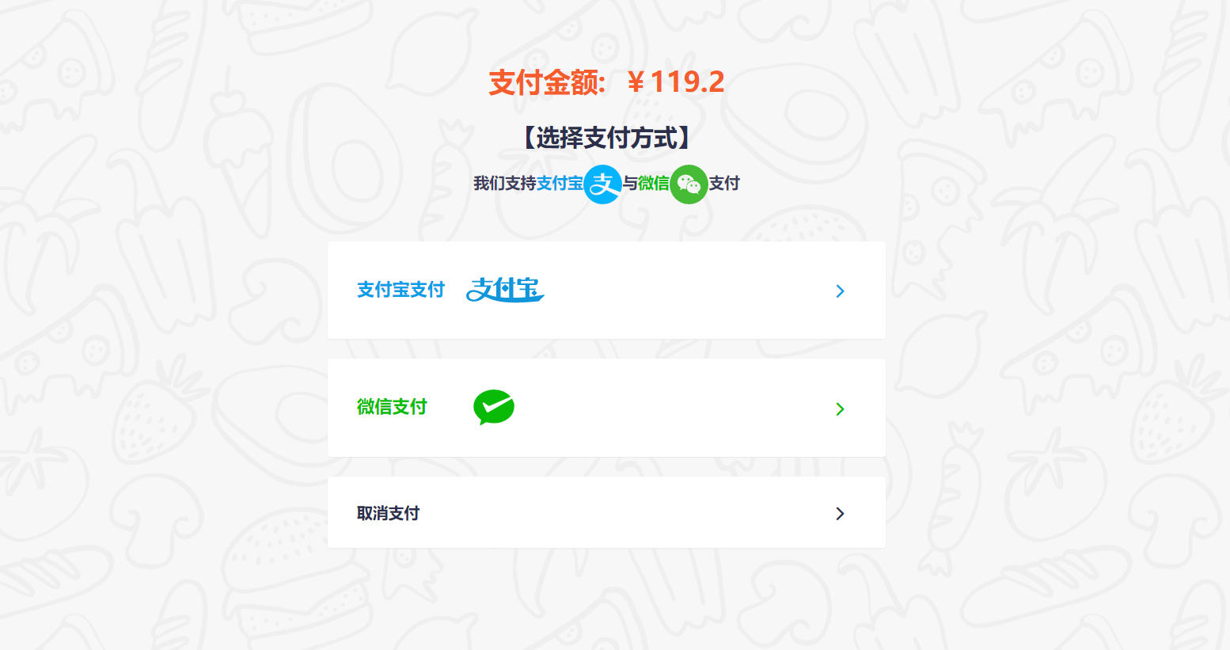

Figure 8.5.2



Figure 8.5.3

The purchase payment page (Figure 8.5.1) is used to display the list of products that the buyer confirms to purchase. The buyer can select and modify the delivery address on this page, and can perform payment operations after confirming that the purchase amount corresponds to the product. The payment page (Figure 8.5.2) displays the amount that the buyer needs to pay, and the user can make the payment through the two payment methods provided (WeChat and Alipay). Figure 8.5.3 is the display of the payment success page.

**8.6 View purchase history**

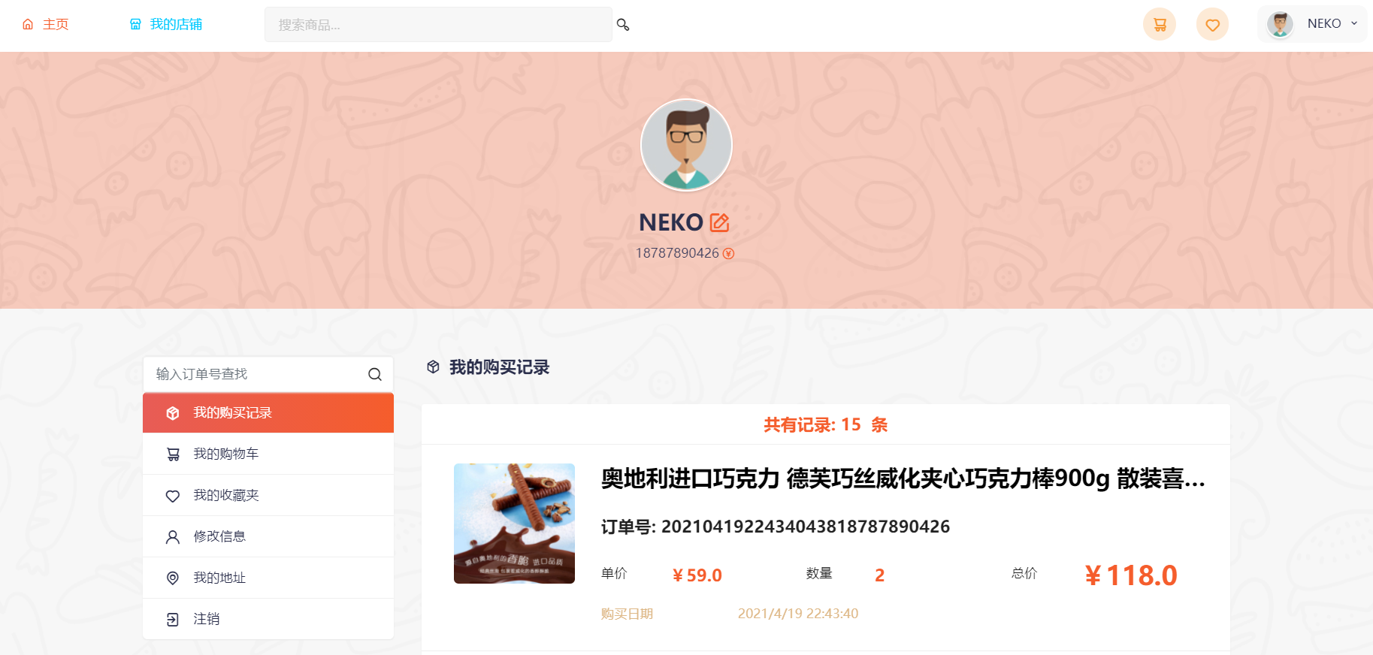

Figure 8.6.1

The View Purchase Record page (Figure 8.6.1) records all purchase records of the buyer. The buyer can view in detail on this page, or enter the order number to filter

**9. References**

* Kathy, Schwalbe. Information Technology Project Management 6th.
* Robert Hughes et al.Software Project Management.5thEdition.2009
* ISO 31000 RISK MANAGEMENT. ISO. <https://www.iso.org/iso-31000-risk-management.html> Accessed 13 April 2020.